SQL MERGE

1-🔷 What is SQL MERGE?
# Source: AI Source: Provided by: [Data Path: Persons Table -> ID Column: 1, Name_En Column: Motasem Essam] -> From: [ChatGPT] on [6/11/2026]
MERGE is a powerful Data Manipulation Language (DML) command used to synchronize two tables by performing INSERT, UPDATE, or DELETE operations in a single command, based on a match condition.
It’s also known as "upsert" (update or insert).

2-✅ Purpose of MERGE
# Source: AI Source: Provided by: [Data Path: Persons Table -> ID Column: 1, Name_En Column: Motasem Essam] -> From: [ChatGPT] on [6/11/2026]
To:
- Update existing records (if match found)
- Insert new records (if no match found)
- Optionally delete records (if match but conditions met)

📌 Syntax (SQL Server / Oracle style):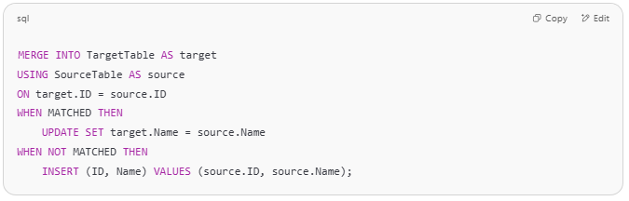
MERGE INTO TargetTable AS target
USING SourceTable AS source
ON target.ID = source.ID
WHEN MATCHED THEN
UPDATE SET target.Name = source.Name
WHEN NOT MATCHED THEN
INSERT (ID, Name) VALUES (source.ID, source.Name);

3-🧠 Example
# Source: AI Source: Provided by: [Data Path: Persons Table -> ID Column: 1, Name_En Column: Motasem Essam] -> From: [ChatGPT] on [6/11/2026]
Tables:
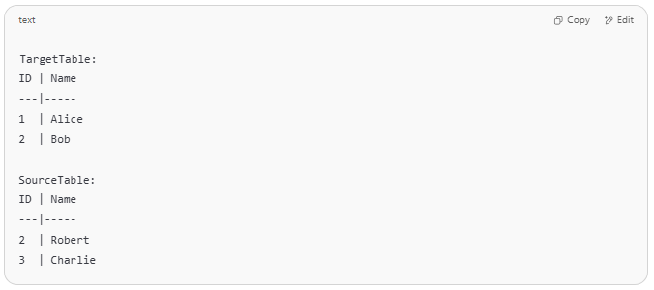
TargetTable:
ID | Name
---|-----
1 | Alice
2 | Bob

SourceTable:
ID | Name
---|-----
2 | Robert
3 | Charlie

MERGE Output:
- Record with ID 2 is updated to Robert
- Record with ID 3 is inserted as Charlie

4-✅ Example Using MERGE (SQL Server / Oracle)

🧾 Tables:
# Source: AI Source: Provided by: [Data Path: Persons Table -> ID Column: 1, Name_En Column: Motasem Essam] -> From: [ChatGPT] on [6/11/2026]
Target table: Employees
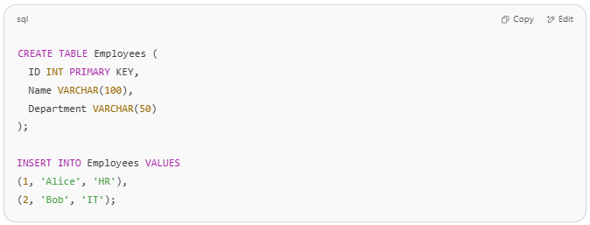
CREATE TABLE Employees (
ID INT PRIMARY KEY,
Name VARCHAR(100),
Department VARCHAR(50)
);

INSERT INTO Employees VALUES
(1, 'Alice', 'HR'),
(2, 'Bob', 'IT');

Source table: NewEmployees
# Source: AI Source: Provided by: [Data Path: Persons Table -> ID Column: 1, Name_En Column: Motasem Essam] -> From: [ChatGPT] on [6/11/2026]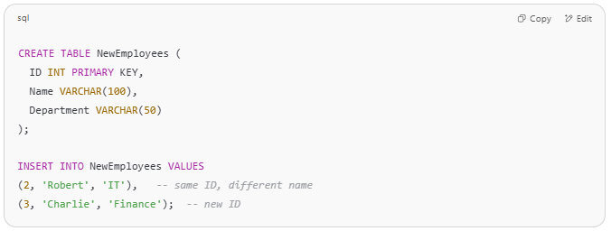
CREATE TABLE NewEmployees (
ID INT PRIMARY KEY,
Name VARCHAR(100),
Department VARCHAR(50)
);

INSERT INTO NewEmployees VALUES
(2, 'Robert', 'IT'), -- same ID, different name
(3, 'Charlie', 'Finance'); -- new ID

🔄 MERGE Statement (SQL Server)
# Source: AI Source: Provided by: [Data Path: Persons Table -> ID Column: 1, Name_En Column: Motasem Essam] -> From: [ChatGPT] on [6/11/2026]

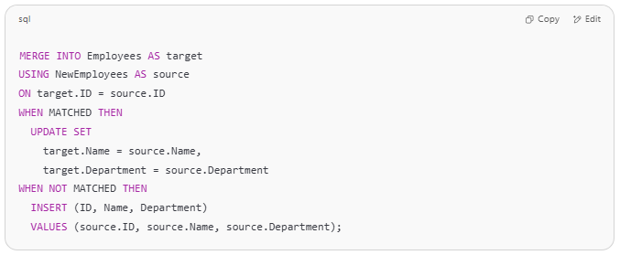
MERGE INTO Employees AS target
USING NewEmployees AS source
ON target.ID = source.ID
WHEN MATCHED THEN
UPDATE SET
target.Name = source.Name,
target.Department = source.Department
WHEN NOT MATCHED THEN
INSERT (ID, Name, Department)
VALUES (source.ID, source.Name, source.Department);

✅ Result in Employees:
ID | Name | Department
1 | Alice | HR
2 | Robert | IT
3 | Charlie | Finance

🔁 MERGE Statement (MySQL)
# Source: AI Source: Provided by: [Data Path: Persons Table -> ID Column: 1, Name_En Column: Motasem Essam] -> From: [ChatGPT] on [6/11/2026]
Since MySQL doesn't support MERGE, you'd use:
👇 1. INSERT ... ON DUPLICATE KEY UPDATE
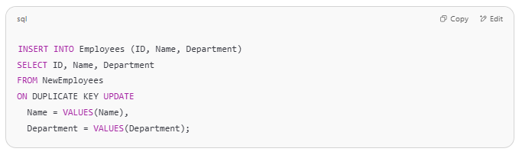
INSERT INTO Employees (ID, Name, Department)
SELECT ID, Name, Department
FROM NewEmployees
ON DUPLICATE KEY UPDATE
Name = VALUES(Name),
Department = VALUES(Department);

This inserts new rows and updates existing ones (based on the ID primary key).
Does not delete — just insert/update.

full SQL script
# Source: AI Source: Provided by: [Data Path: Persons Table -> ID Column: 1, Name_En Column: Motasem Essam] -> From: [ChatGPT] on [6/11/2026]
Great! Here's a full working SQL script for testing MERGE in:

🔷 1. SQL Server – Full MERGE Script
# Source: AI Source: Provided by: [Data Path: Persons Table -> ID Column: 1, Name_En Column: Motasem Essam] -> From: [ChatGPT] on [6/11/2026]
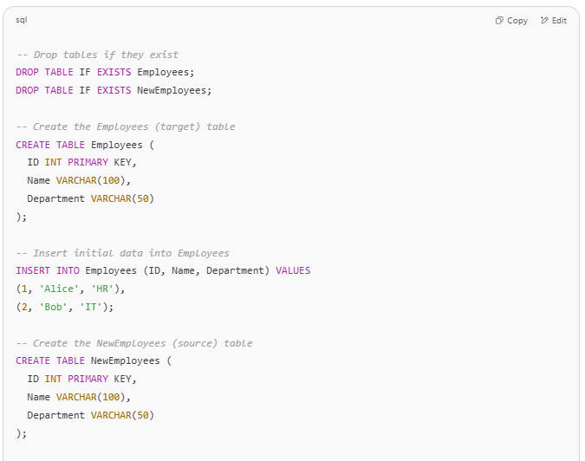
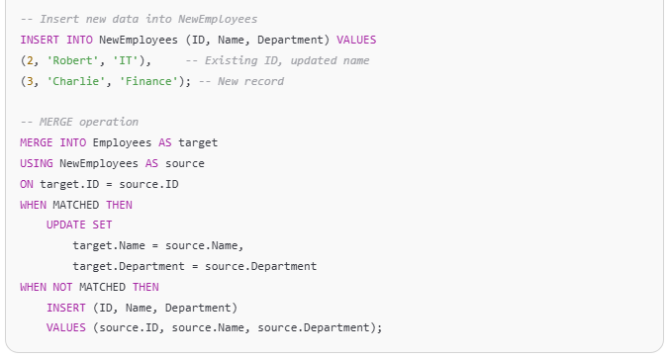
-- Drop tables if they exist
DROP TABLE IF EXISTS Employees;
DROP TABLE IF EXISTS NewEmployees;

-- Create the Employees (target) table
CREATE TABLE Employees (
ID INT PRIMARY KEY,
Name VARCHAR(100),
Department VARCHAR(50)
);

-- Insert initial data into Employees
INSERT INTO Employees (ID, Name, Department) VALUES
(1, 'Alice', 'HR'),
(2, 'Bob', 'IT');

-- Create the NewEmployees (source) table
CREATE TABLE NewEmployees (
ID INT PRIMARY KEY,
Name VARCHAR(100),
Department VARCHAR(50)
);

-- Insert new data into NewEmployees
INSERT INTO NewEmployees (ID, Name, Department) VALUES
(2, 'Robert', 'IT'), -- Existing ID, updated name
(3, 'Charlie', 'Finance'); -- New record

-- MERGE operation
MERGE INTO Employees AS target
USING NewEmployees AS source
ON target.ID = source.ID
WHEN MATCHED THEN
UPDATE SET
target.Name = source.Name,
target.Department = source.Department
WHEN NOT MATCHED THEN
INSERT (ID, Name, Department)
VALUES (source.ID, source.Name, source.Department);

✅ Expected Output (in Employees table):
# Source: AI Source: Provided by: [Data Path: Persons Table -> ID Column: 1, Name_En Column: Motasem Essam] -> From: [ChatGPT] on [6/11/2026]
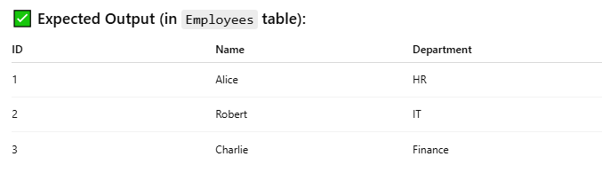
ID | Name | Department
1 | Alice | HR
2 | Robert | IT
3 | Charlie | Finance

🔶 2. MySQL – Equivalent with INSERT ... ON DUPLICATE KEY UPDATE
# Source: AI Source: Provided by: [Data Path: Persons Table -> ID Column: 1, Name_En Column: Motasem Essam] -> From: [ChatGPT] on [6/11/2026]

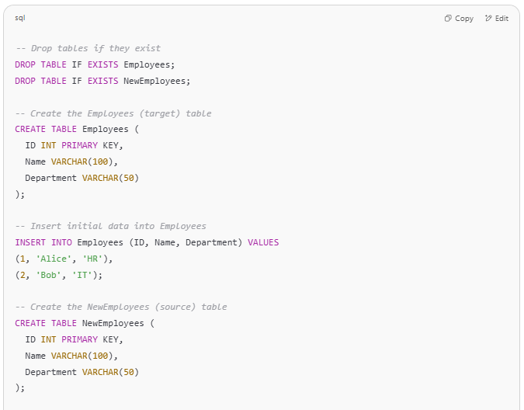
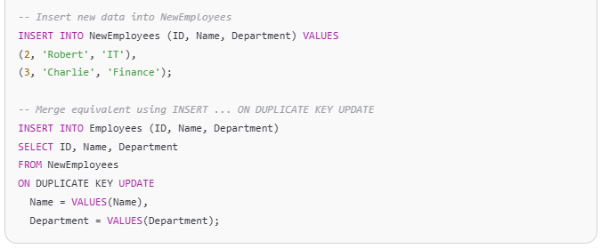
-- Drop tables if they exist
DROP TABLE IF EXISTS Employees;
DROP TABLE IF EXISTS NewEmployees;

-- Create the Employees (target) table
CREATE TABLE Employees (
ID INT PRIMARY KEY,
Name VARCHAR(100),
Department VARCHAR(50)
);

-- Insert initial data into Employees
INSERT INTO Employees (ID, Name, Department) VALUES
(1, 'Alice', 'HR'),
(2, 'Bob', 'IT');

-- Create the NewEmployees (source) table
CREATE TABLE NewEmployees (
ID INT PRIMARY KEY,
Name VARCHAR(100),
Department VARCHAR(50)
);

-- Insert new data into NewEmployees
INSERT INTO NewEmployees (ID, Name, Department) VALUES
(2, 'Robert', 'IT'),
(3, 'Charlie', 'Finance');

-- Merge equivalent using INSERT ... ON DUPLICATE KEY UPDATE
INSERT INTO Employees (ID, Name, Department)
SELECT ID, Name, Department
FROM NewEmployees
ON DUPLICATE KEY UPDATE
Name = VALUES(Name),
Department = VALUES(Department);

✅ Same Output in MySQL (Employees table):
# Source: AI Source: Provided by: [Data Path: Persons Table -> ID Column: 1, Name_En Column: Motasem Essam] -> From: [ChatGPT] on [6/11/2026]
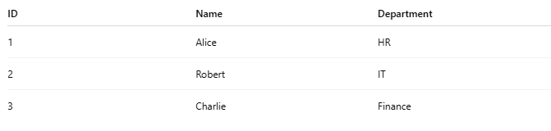
ID | Name | Department
1 | Alice | HR
2 | Robert | IT
3 | Charlie | Finance

🧠 Summary
# Source: AI Source: Provided by: [Data Path: Persons Table -> ID Column: 1, Name_En Column: Motasem Essam] -> From: [ChatGPT] on [6/11/2026]
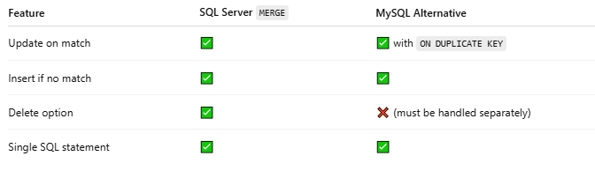

Feature | SQL Server MERGE | MySQL Alternative
Update on match | ✅ | ✅ with ON DUPLICATE KEY
Insert if no match | ✅ | ✅
Delete option | ✅ | ❌ (must be handled separately)
Single SQL statement | ✅ | ✅

Example

prepared commands
# Source: ScreenShot Source: Provided by: [Persons Table -> ID Column: 1, Name_En Column: Motasem Essam] -> Tool: [Automation Table -> ID Column: 16, Name_En Column: Screen Capture] -> From [Operating System: Wampserver64 -> phpmyadmin] on [6/11/2026]
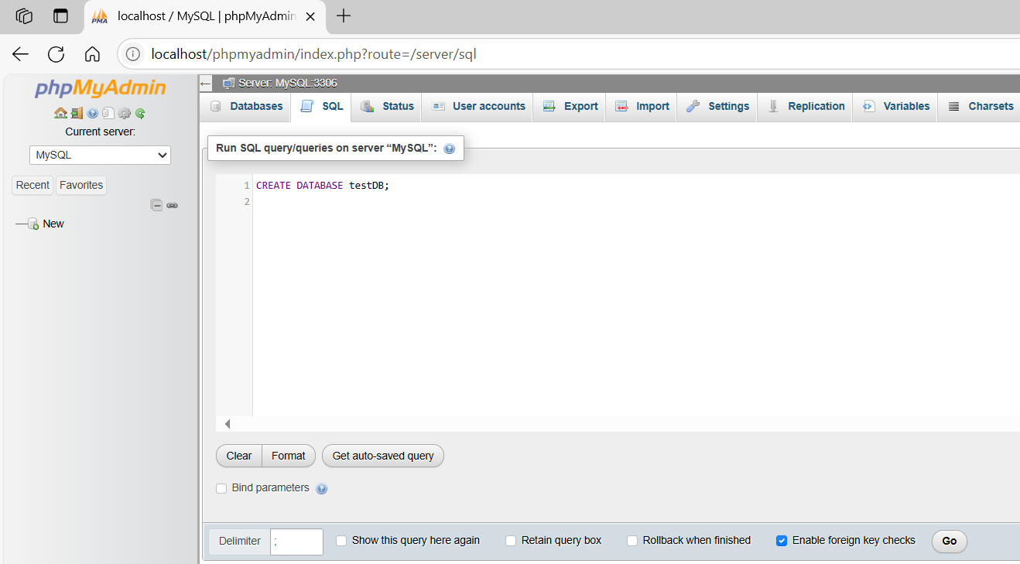
CREATE DATABASE testDB;
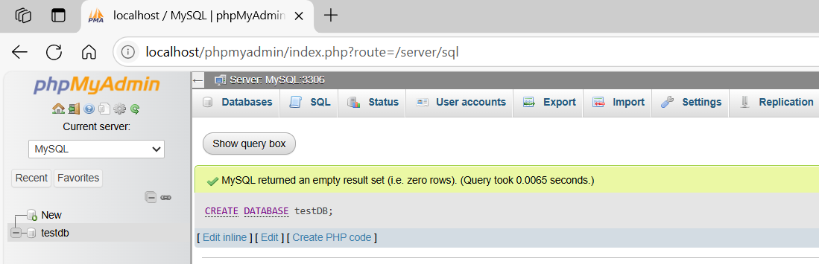
✅ Step 1: Create Tables
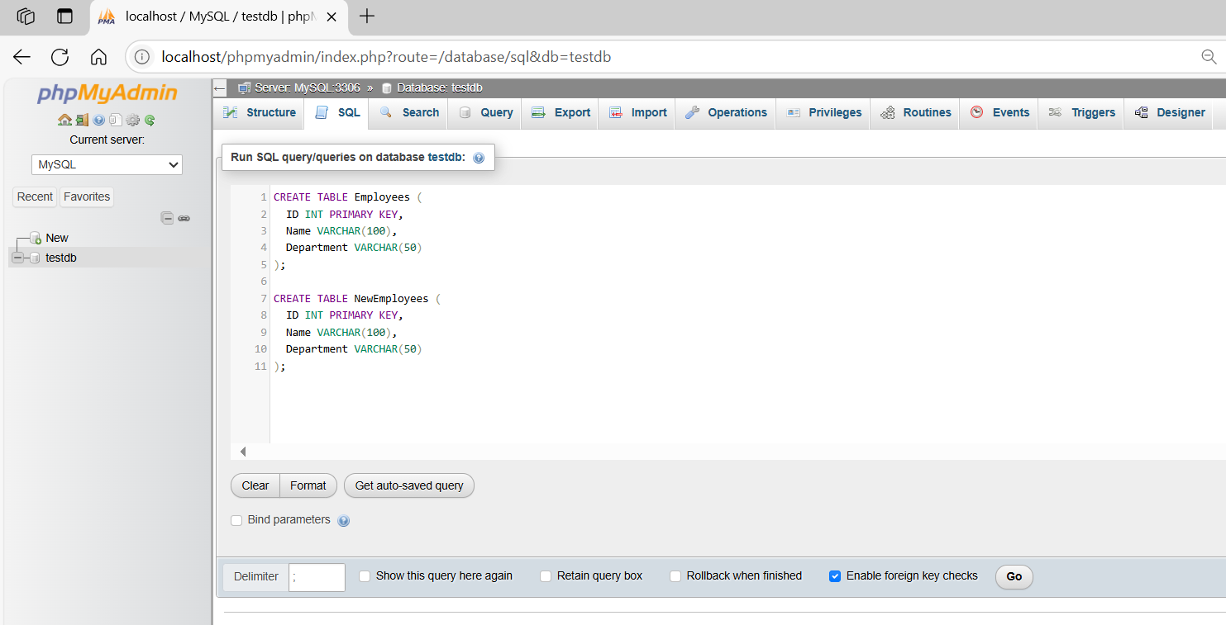
CREATE TABLE Employees (
ID INT PRIMARY KEY,
Name VARCHAR(100),
Department VARCHAR(50)
);

CREATE TABLE NewEmployees (
ID INT PRIMARY KEY,
Name VARCHAR(100),
Department VARCHAR(50)
);
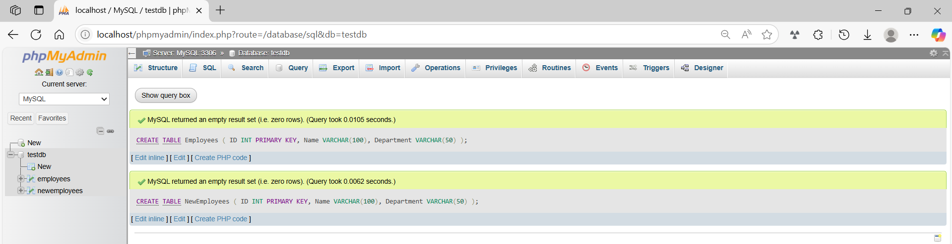

✅ Step 2: Insert Data
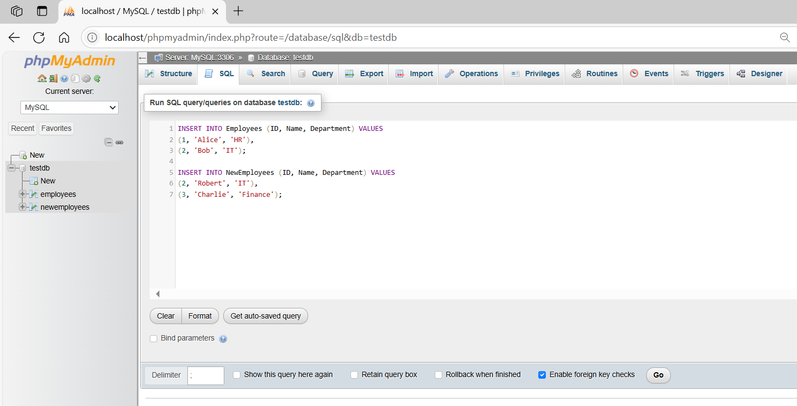
INSERT INTO Employees (ID, Name, Department) VALUES
(1, 'Alice', 'HR'),
(2, 'Bob', 'IT');

INSERT INTO NewEmployees (ID, Name, Department) VALUES
(2, 'Robert', 'IT'),
(3, 'Charlie', 'Finance');
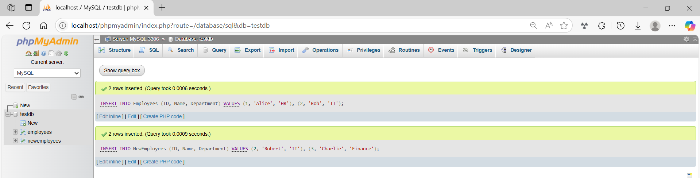
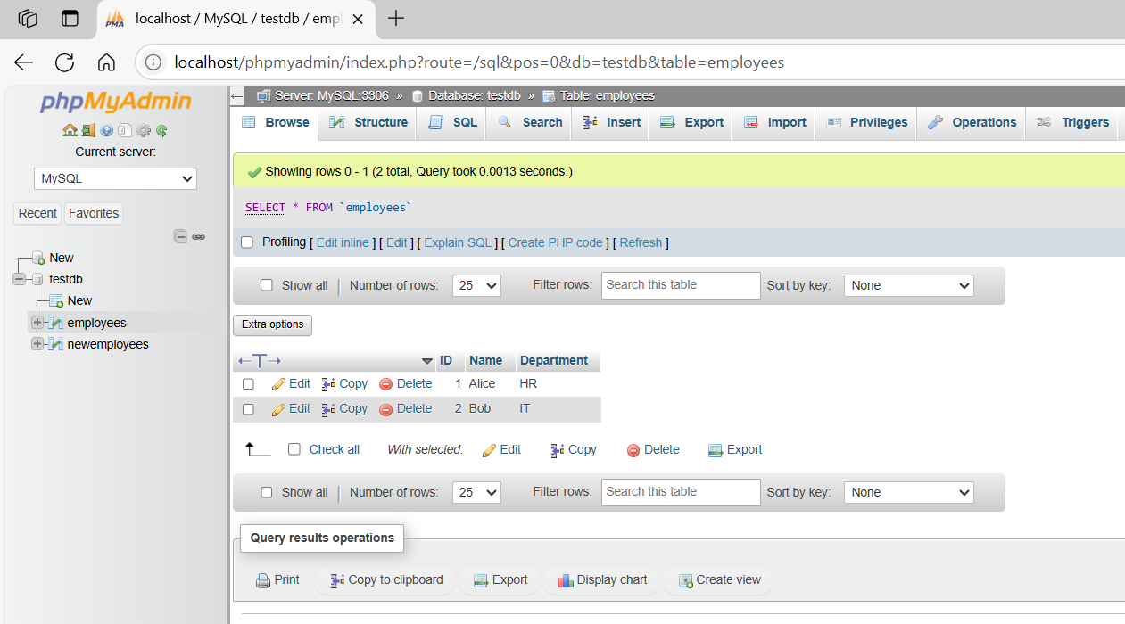
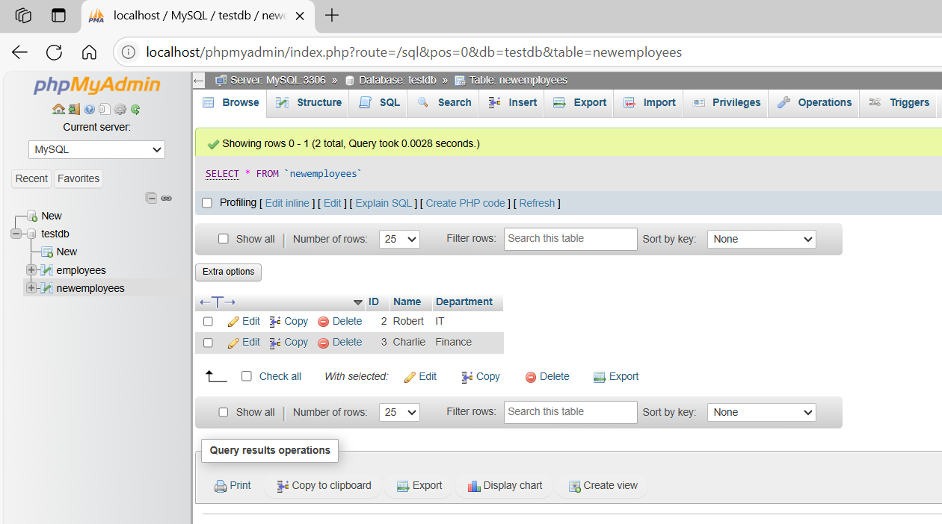

basic command
# Source: ScreenShot Source: Provided by: [Persons Table -> ID Column: 1, Name_En Column: Motasem Essam] -> Tool: [Automation Table -> ID Column: 16, Name_En Column: Screen Capture] -> From [Operating System: Wampserver64 -> phpmyadmin] on [6/11/2026]
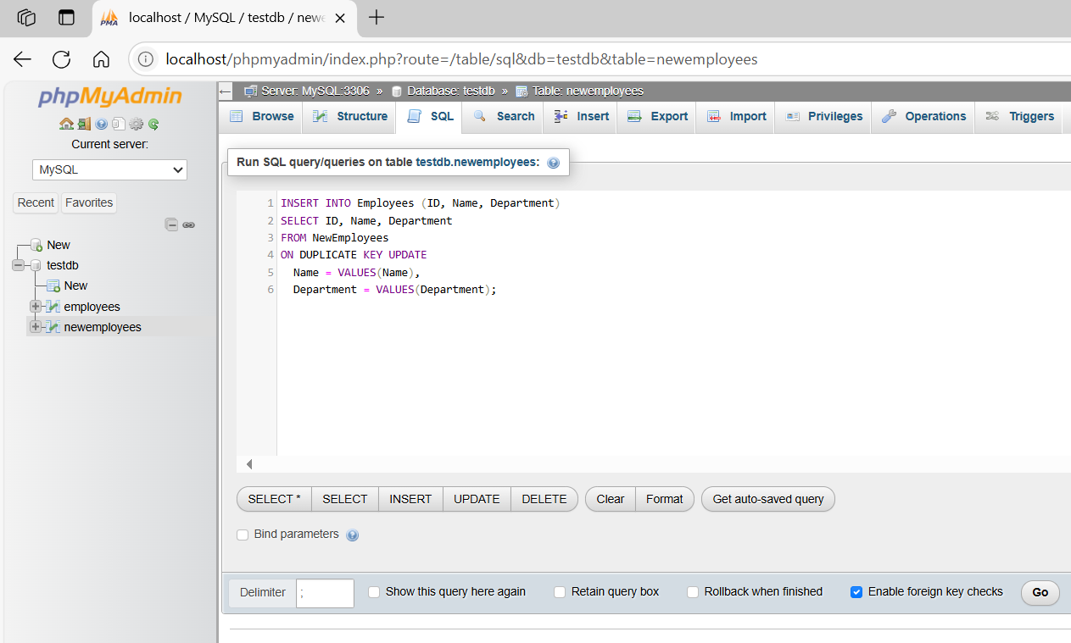
INSERT INTO Employees (ID, Name, Department)
SELECT ID, Name, Department
FROM NewEmployees
ON DUPLICATE KEY UPDATE
Name = VALUES(Name),
Department = VALUES(Department);
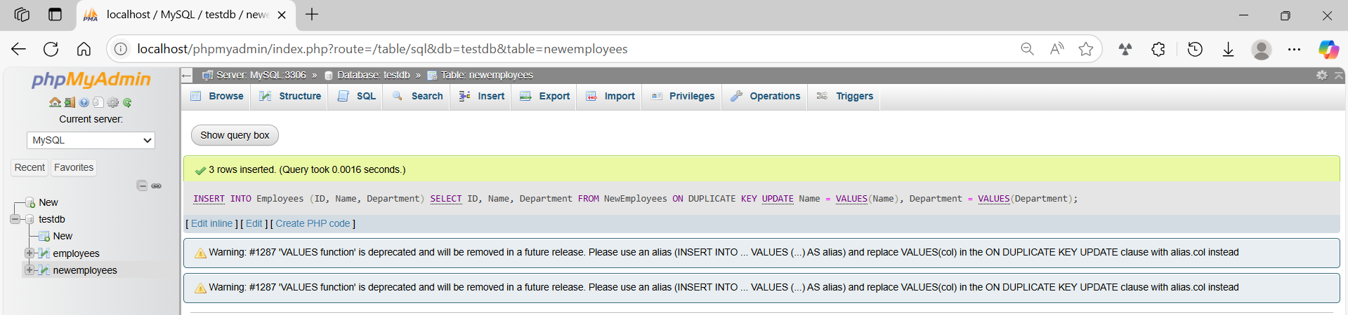
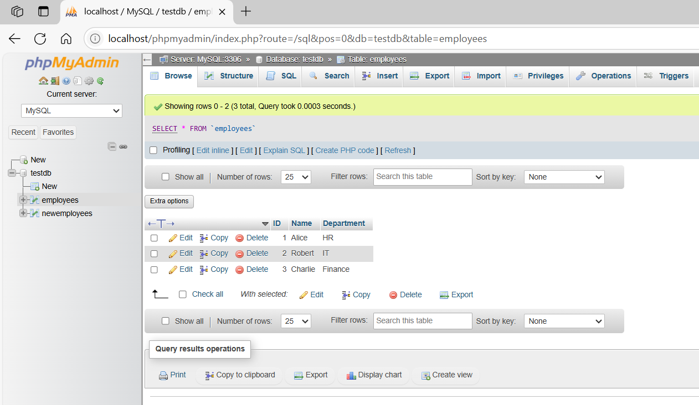
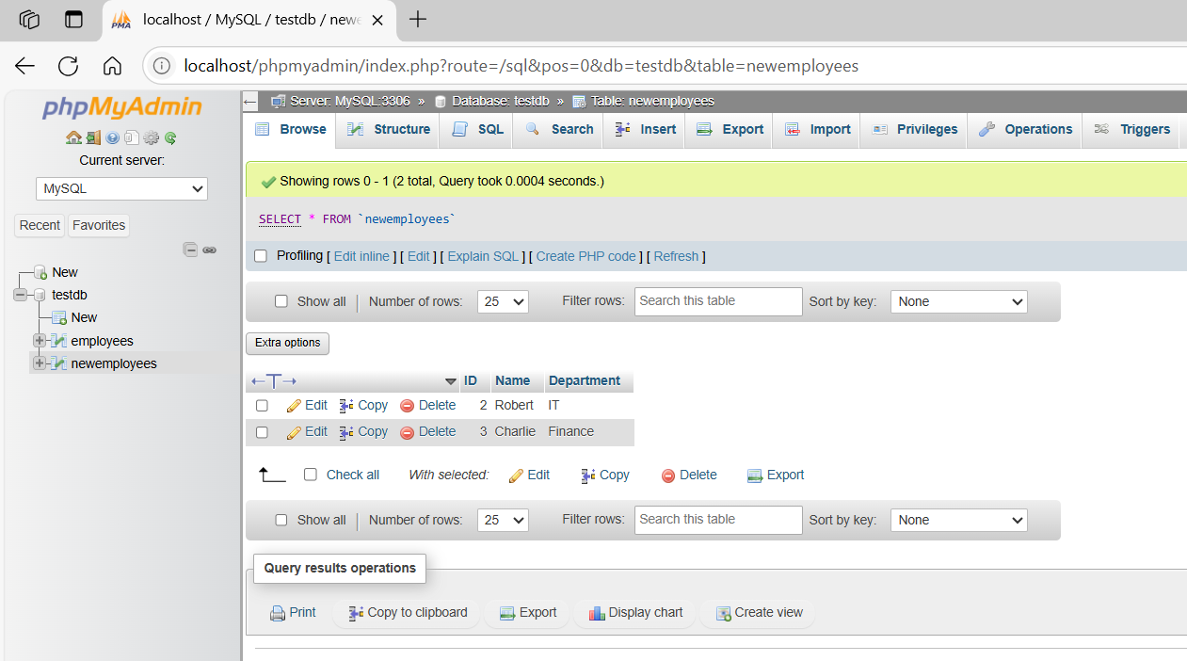

5- Example with DELETE logic SQL Server
# Source: AI Source: Provided by: [Data Path: Persons Table -> ID Column: 1, Name_En Column: Motasem Essam] -> From: [ChatGPT] on [6/11/2026]
Sure! Here’s a full MERGE example with DELETE logic — supported in SQL Server.

Example: MERGE with DELETE in SQL Server
# Source: AI Source: Provided by: [Data Path: Persons Table -> ID Column: 1, Name_En Column: Motasem Essam] -> From: [ChatGPT] on [6/11/2026]
We will:
- UPDATE rows that match
- INSERT rows that don't exist
- DELETE rows in the target that are not in the source

🧱 Step-by-Step Setup

1. Drop and Create Tables
# Source: AI Source: Provided by: [Data Path: Persons Table -> ID Column: 1, Name_En Column: Motasem Essam] -> From: [ChatGPT] on [6/11/2026]
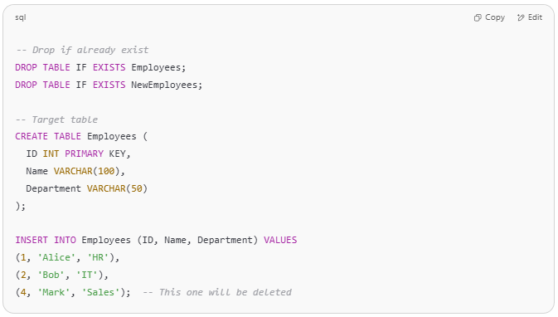
-- Drop if already exist
DROP TABLE IF EXISTS Employees;
DROP TABLE IF EXISTS NewEmployees;

-- Target table
CREATE TABLE Employees (
ID INT PRIMARY KEY,
Name VARCHAR(100),
Department VARCHAR(50)
);

INSERT INTO Employees (ID, Name, Department) VALUES
(1, 'Alice', 'HR'),
(2, 'Bob', 'IT'),
(4, 'Mark', 'Sales'); -- This one will be deleted

2. Create Source Table
# Source: AI Source: Provided by: [Data Path: Persons Table -> ID Column: 1, Name_En Column: Motasem Essam] -> From: [ChatGPT] on [6/11/2026]
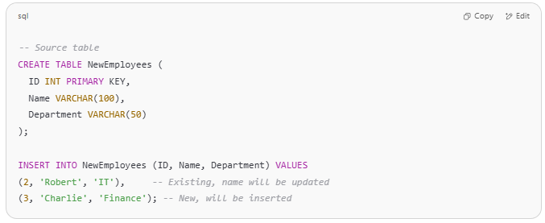
-- Source table
CREATE TABLE NewEmployees (
ID INT PRIMARY KEY,
Name VARCHAR(100),
Department VARCHAR(50)
);

INSERT INTO NewEmployees (ID, Name, Department) VALUES
(2, 'Robert', 'IT'), -- Existing, name will be updated
(3, 'Charlie', 'Finance'); -- New, will be inserted

3. MERGE with DELETE
# Source: AI Source: Provided by: [Data Path: Persons Table -> ID Column: 1, Name_En Column: Motasem Essam] -> From: [ChatGPT] on [6/11/2026]
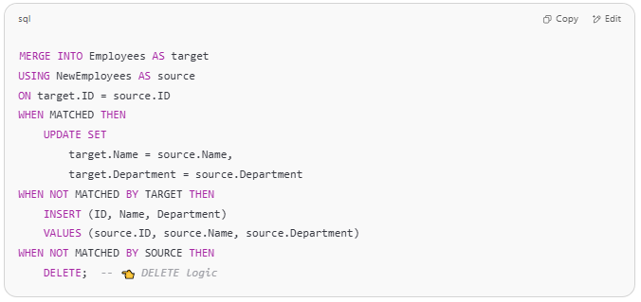
MERGE INTO Employees AS target
USING NewEmployees AS source
ON target.ID = source.ID
WHEN MATCHED THEN
UPDATE SET
target.Name = source.Name,
target.Department = source.Department
WHEN NOT MATCHED BY TARGET THEN
INSERT (ID, Name, Department)
VALUES (source.ID, source.Name, source.Department)
WHEN NOT MATCHED BY SOURCE THEN
DELETE; -- 👈 DELETE logic

✅ Final Output in Employees Table:
# Source: AI Source: Provided by: [Data Path: Persons Table -> ID Column: 1, Name_En Column: Motasem Essam] -> From: [ChatGPT] on [6/11/2026]
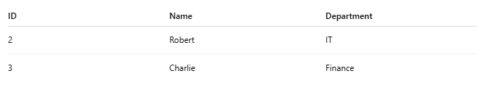

ID | Name | Department
2 | Robert | IT
3 | Charlie | Finance

❌ Row with ID = 1 and ID = 4 are deleted because they’re not in the source.

⚠️ MySQL Note
# Source: AI Source: Provided by: [Data Path: Persons Table -> ID Column: 1, Name_En Column: Motasem Essam] -> From: [ChatGPT] on [6/11/2026]
MySQL does not support MERGE or this DELETE behavior in a single statement. You'd need separate steps:
- Sync/insert using INSERT ... ON DUPLICATE KEY UPDATE
- Then manually delete rows not present in source with DELETE ... WHERE NOT EXISTS

Example with DELETE logic MySQL

MySQL Equivalent to MERGE with DELETE
# Source: AI Source: Provided by: [Data Path: Persons Table -> ID Column: 1, Name_En Column: Motasem Essam] -> From: [ChatGPT] on [6/11/2026]
We’ll:
- Insert or update matching records.
- Delete records in the target that don’t exist in the source.

🧱 Step 1: Create Tables
# Source: AI Source: Provided by: [Data Path: Persons Table -> ID Column: 1, Name_En Column: Motasem Essam] -> From: [ChatGPT] on [6/11/2026]
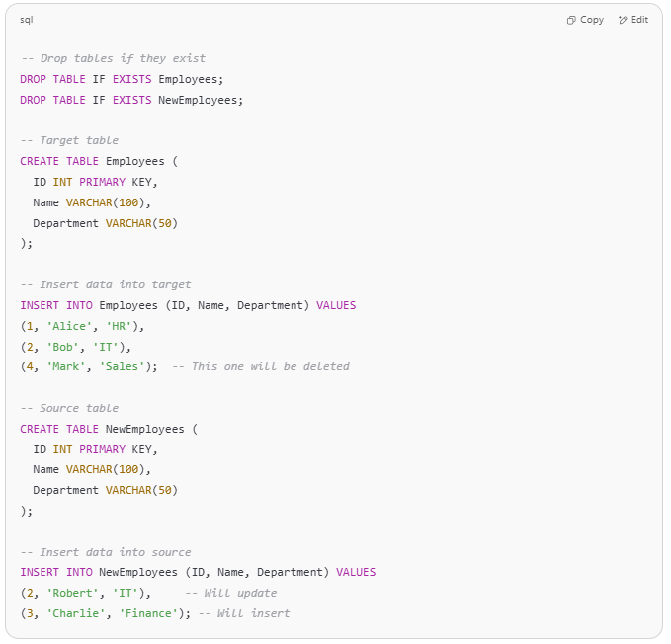
-- Drop tables if they exist
DROP TABLE IF EXISTS Employees;
DROP TABLE IF EXISTS NewEmployees;

-- Target table
CREATE TABLE Employees (
ID INT PRIMARY KEY,
Name VARCHAR(100),
Department VARCHAR(50)
);

-- Insert data into target
INSERT INTO Employees (ID, Name, Department) VALUES
(1, 'Alice', 'HR'),
(2, 'Bob', 'IT'),
(4, 'Mark', 'Sales'); -- This one will be deleted

-- Source table
CREATE TABLE NewEmployees (
ID INT PRIMARY KEY,
Name VARCHAR(100),
Department VARCHAR(50)
);

-- Insert data into source
INSERT INTO NewEmployees (ID, Name, Department) VALUES
(2, 'Robert', 'IT'), -- Will update
(3, 'Charlie', 'Finance'); -- Will insert

🔁 Step 2: Insert or Update (Upsert)
# Source: AI Source: Provided by: [Data Path: Persons Table -> ID Column: 1, Name_En Column: Motasem Essam] -> From: [ChatGPT] on [6/11/2026]
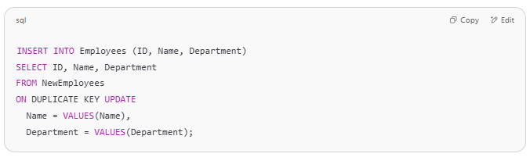
INSERT INTO Employees (ID, Name, Department)
SELECT ID, Name, Department
FROM NewEmployees
ON DUPLICATE KEY UPDATE
Name = VALUES(Name),
Department = VALUES(Department);

✅ This inserts ID 3 and updates ID 2.

❌ Step 3: Delete Records Not in Source
# Source: AI Source: Provided by: [Data Path: Persons Table -> ID Column: 1, Name_En Column: Motasem Essam] -> From: [ChatGPT] on [6/11/2026]
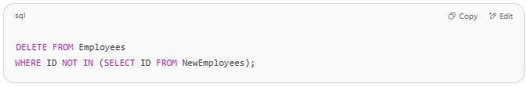
DELETE FROM Employees
WHERE ID NOT IN (SELECT ID FROM NewEmployees);

✅ This deletes ID 1 and 4 — they don’t exist in NewEmployees.

✅ Final Data in Employees
# Source: AI Source: Provided by: [Data Path: Persons Table -> ID Column: 1, Name_En Column: Motasem Essam] -> From: [ChatGPT] on [6/11/2026]
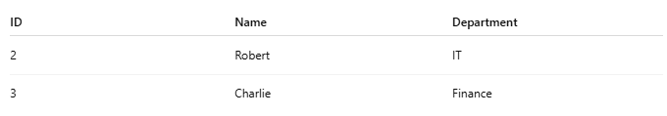

ID | Name | Department
2 | Robert | IT
3 | Charlie | Finance

Example

prepared commands
# Source: ScreenShot Source: Provided by: [Persons Table -> ID Column: 1, Name_En Column: Motasem Essam] -> Tool: [Automation Table -> ID Column: 16, Name_En Column: Screen Capture] -> From [Operating System: Wampserver64 -> phpmyadmin] on [6/11/2026]

CREATE DATABASE testDB;

✅ Step 1: Create Tables
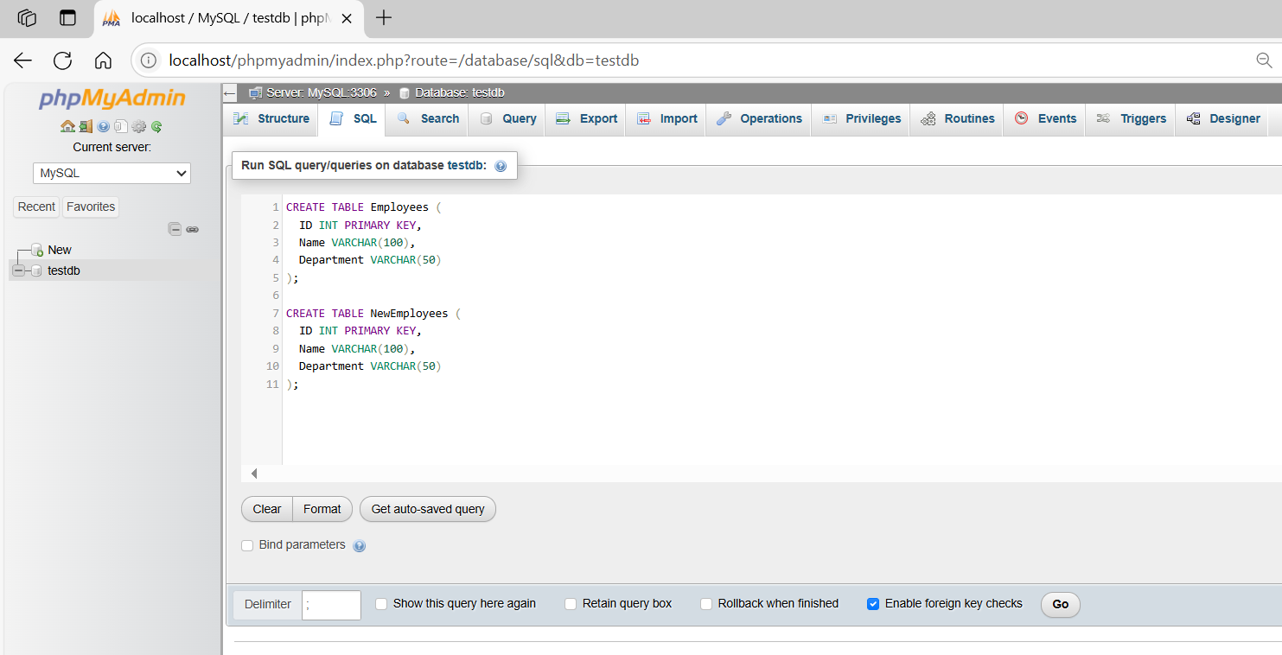
CREATE TABLE Employees (
ID INT PRIMARY KEY,
Name VARCHAR(100),
Department VARCHAR(50)
);

CREATE TABLE NewEmployees (
ID INT PRIMARY KEY,
Name VARCHAR(100),
Department VARCHAR(50)
);
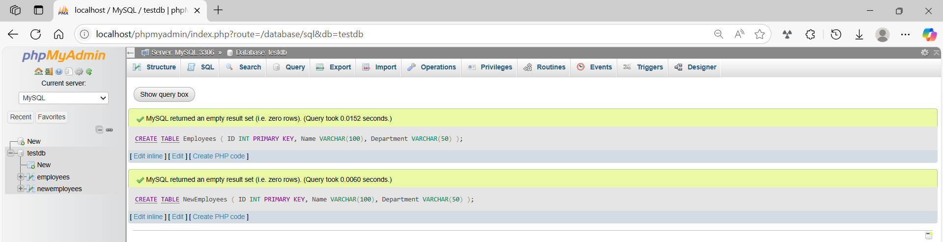
✅ Step 2: Insert Data
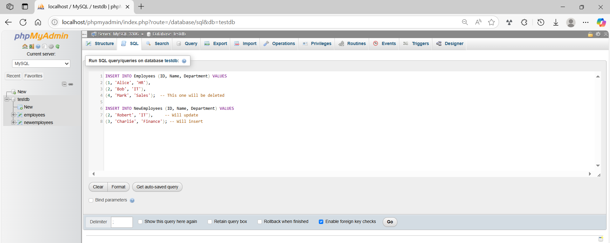
INSERT INTO Employees (ID, Name, Department) VALUES
(1, 'Alice', 'HR'),
(2, 'Bob', 'IT'),
(4, 'Mark', 'Sales'); -- This one will be deleted

INSERT INTO NewEmployees (ID, Name, Department) VALUES
(2, 'Robert', 'IT'), -- Will update
(3, 'Charlie', 'Finance'); -- Will insert
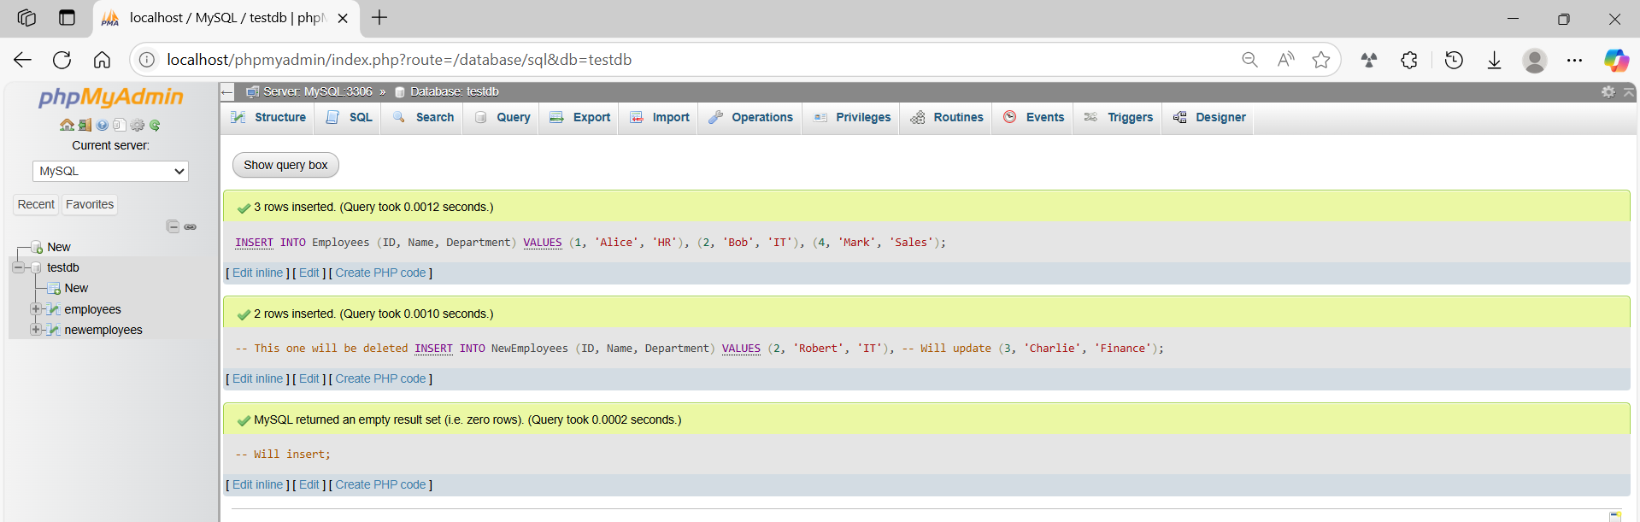
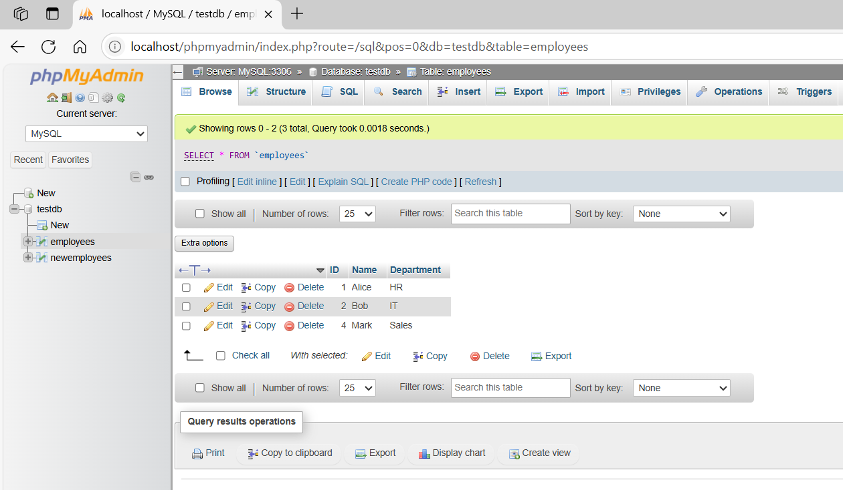
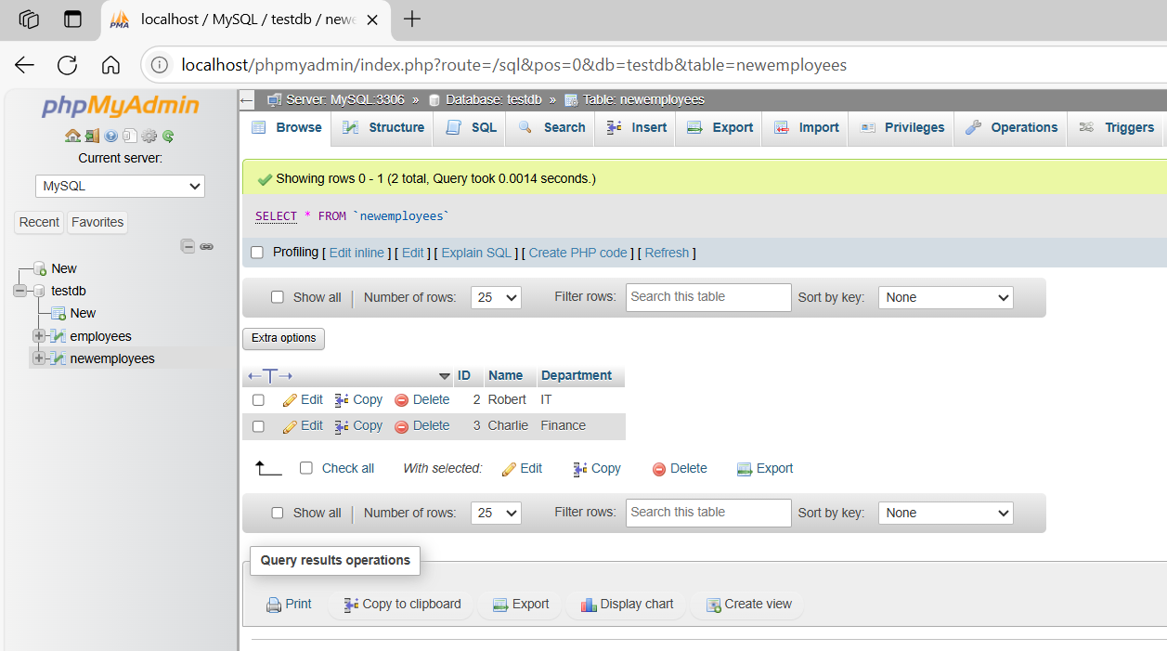
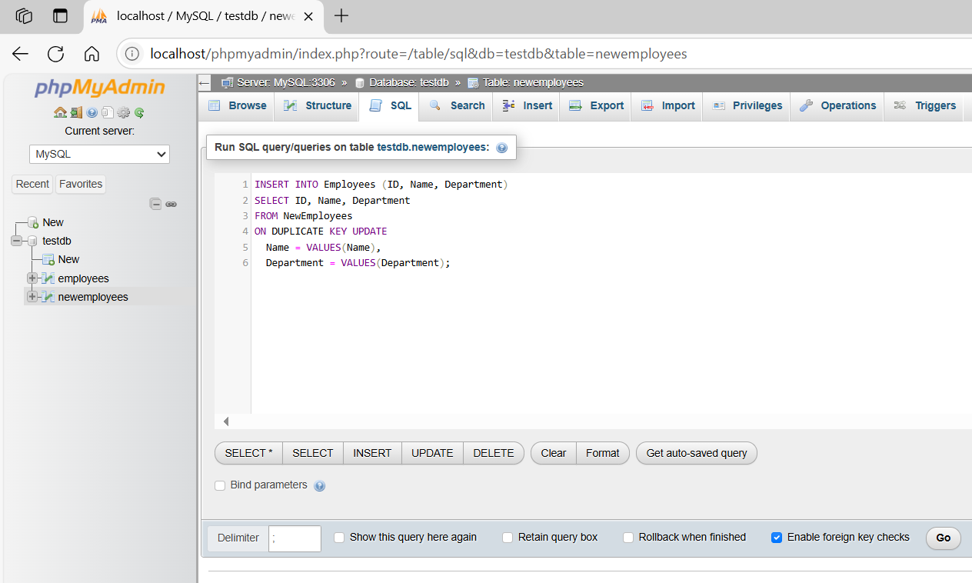
INSERT INTO Employees (ID, Name, Department)
SELECT ID, Name, Department
FROM NewEmployees
ON DUPLICATE KEY UPDATE
Name = VALUES(Name),
Department = VALUES(Department);
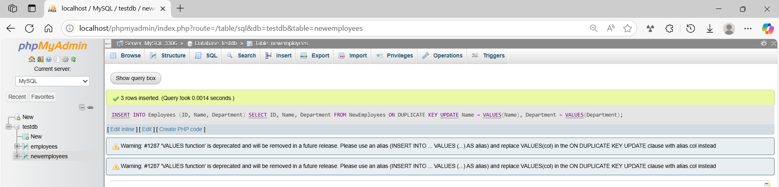
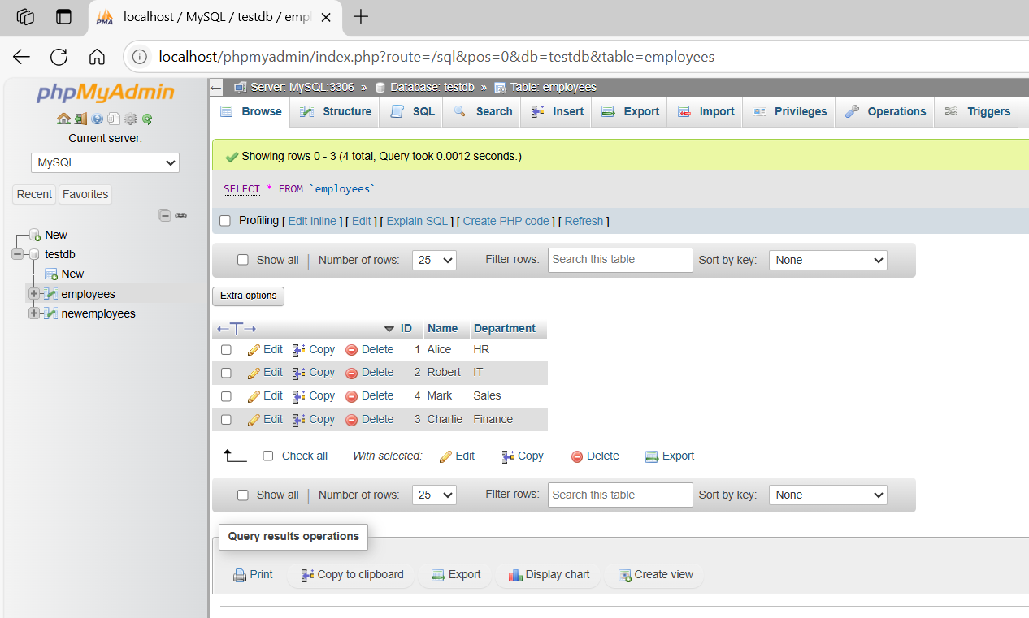

basic command
# Source: ScreenShot Source: Provided by: [Persons Table -> ID Column: 1, Name_En Column: Motasem Essam] -> Tool: [Automation Table -> ID Column: 16, Name_En Column: Screen Capture] -> From [Operating System: Wampserver64 -> phpmyadmin] on [6/11/2026]
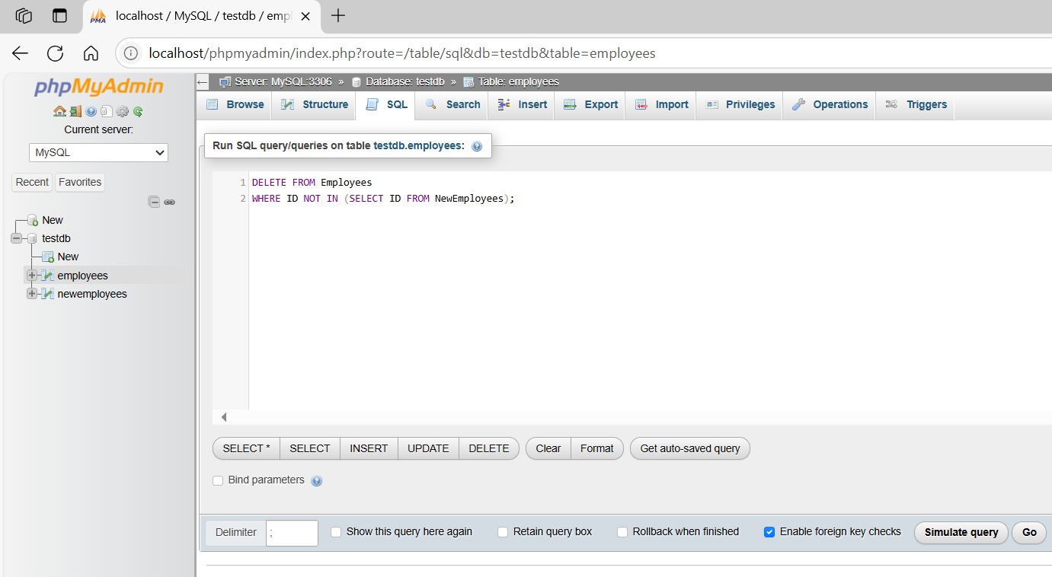
DELETE FROM Employees
WHERE ID NOT IN (SELECT ID FROM NewEmployees);
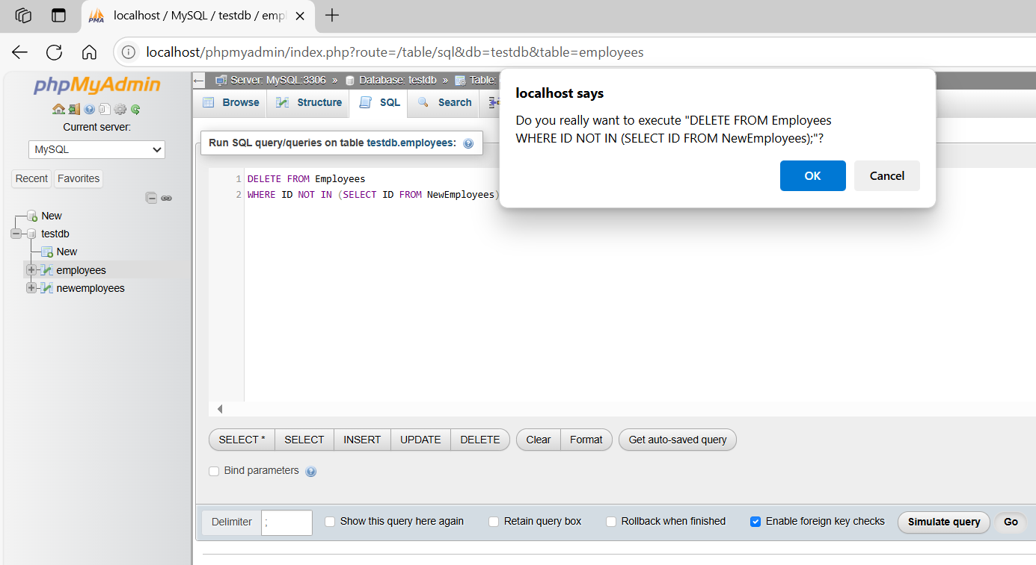
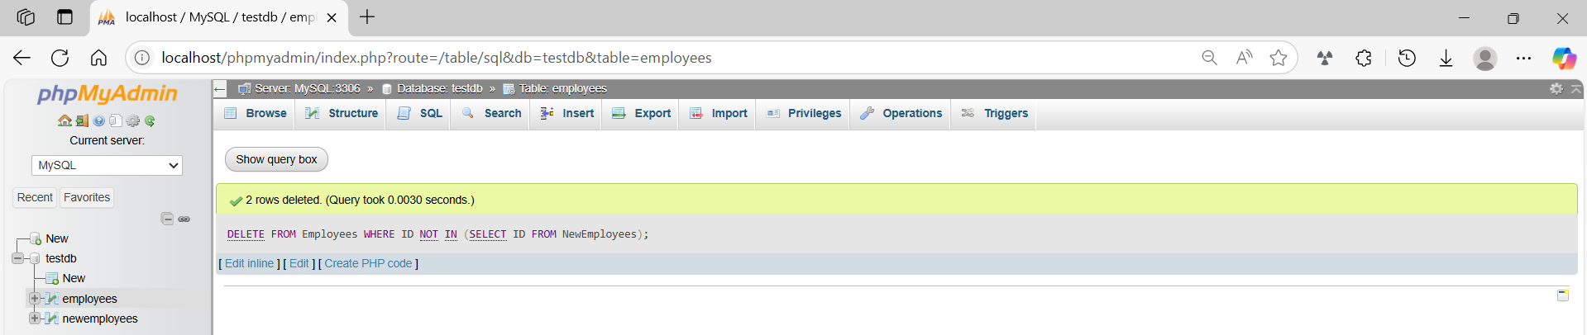
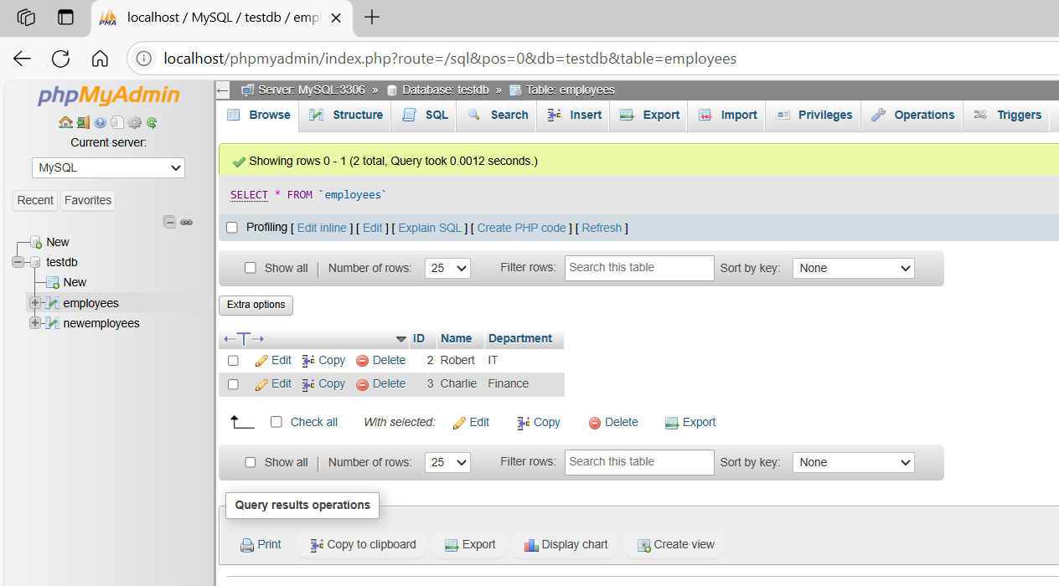
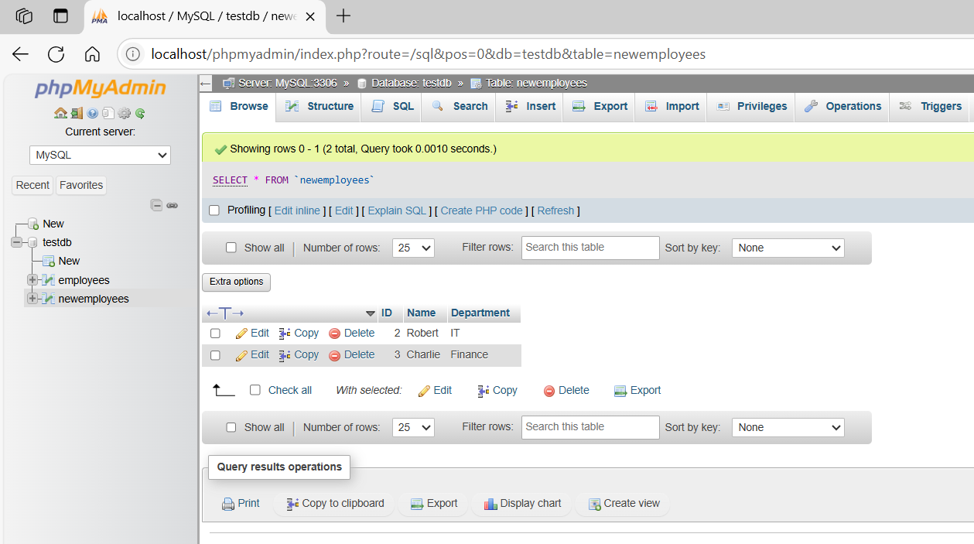

6-More advanced MERGE use cases

SQL Server
# Source: AI Source: Provided by: [Data Path: Persons Table -> ID Column: 1, Name_En Column: Motasem Essam] -> From: [ChatGPT] on [6/11/2026]
Great! Let’s dive into more advanced SQL MERGE use cases, particularly in SQL Server (since it's the main platform that supports full MERGE functionality). These examples will show how to:
- 🔄 Update only changed data (to avoid unnecessary writes)
- ❌ Soft delete missing rows (using a flag)
- 🔄 Merge multiple columns with conditional logic
- 🧾 Audit merged records
- 🧠 Merge with complex JOIN conditions

✅ Use Case 1: Update Only If Data Is Different
# Source: AI Source: Provided by: [Data Path: Persons Table -> ID Column: 1, Name_En Column: Motasem Essam] -> From: [ChatGPT] on [6/11/2026]
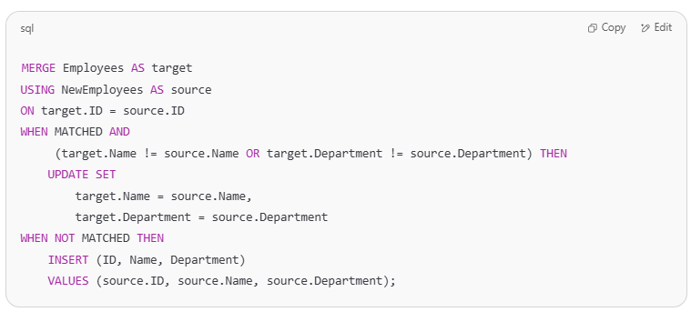
MERGE Employees AS target
USING NewEmployees AS source
ON target.ID = source.ID
WHEN MATCHED AND
(target.Name != source.Name OR target.Department != source.Department) THEN
UPDATE SET
target.Name = source.Name,
target.Department = source.Department
WHEN NOT MATCHED THEN
INSERT (ID, Name, Department)
VALUES (source.ID, source.Name, source.Department);

🧠 This avoids unnecessary updates when data hasn’t actually changed.

✅ Use Case 2: Soft Delete Instead of Hard Delete
# Source: AI Source: Provided by: [Data Path: Persons Table -> ID Column: 1, Name_En Column: Motasem Essam] -> From: [ChatGPT] on [6/11/2026]
Assume the Employees table has an IsActive column (bit or boolean).
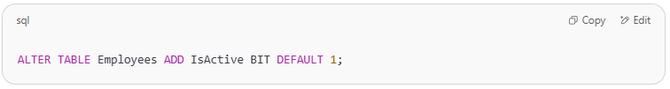
ALTER TABLE Employees ADD IsActive BIT DEFAULT 1;

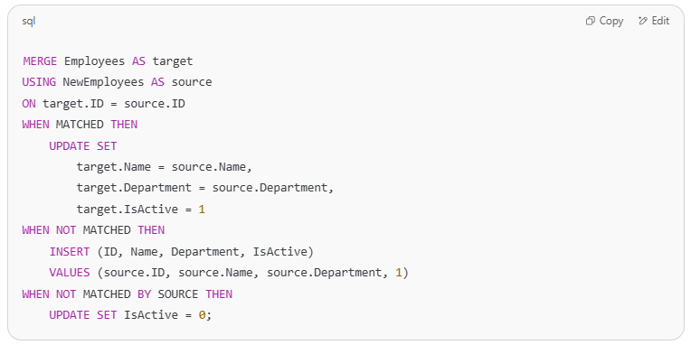
MERGE Employees AS target
USING NewEmployees AS source
ON target.ID = source.ID
WHEN MATCHED THEN
UPDATE SET
target.Name = source.Name,
target.Department = source.Department,
target.IsActive = 1
WHEN NOT MATCHED THEN
INSERT (ID, Name, Department, IsActive)
VALUES (source.ID, source.Name, source.Department, 1)
WHEN NOT MATCHED BY SOURCE THEN
UPDATE SET IsActive = 0;

💡 Instead of deleting records, we just mark them as inactive.

✅ Use Case 3: Conditional Merge Logic Based on Columns
# Source: AI Source: Provided by: [Data Path: Persons Table -> ID Column: 1, Name_En Column: Motasem Essam] -> From: [ChatGPT] on [6/11/2026]
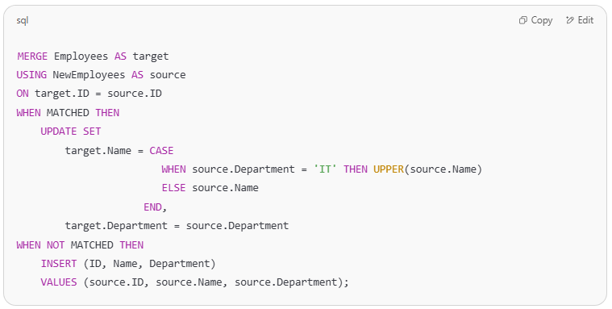
MERGE Employees AS target
USING NewEmployees AS source
ON target.ID = source.ID
WHEN MATCHED THEN
UPDATE SET
target.Name = CASE
WHEN source.Department = 'IT' THEN UPPER(source.Name)
ELSE source.Name
END,
target.Department = source.Department
WHEN NOT MATCHED THEN
INSERT (ID, Name, Department)
VALUES (source.ID, source.Name, source.Department);

🧠 If the department is IT, convert the name to uppercase during update.

✅ Use Case 4: Merge with Logging (Audit Table)
# Source: AI Source: Provided by: [Data Path: Persons Table -> ID Column: 1, Name_En Column: Motasem Essam] -> From: [ChatGPT] on [6/11/2026]
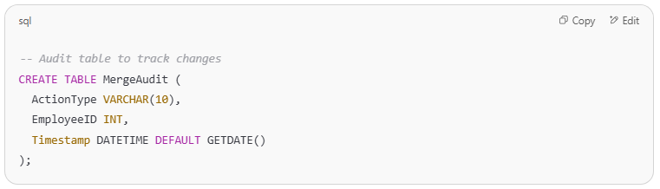
-- Audit table to track changes
CREATE TABLE MergeAudit (
ActionType VARCHAR(10),
EmployeeID INT,
Timestamp DATETIME DEFAULT GETDATE()
);

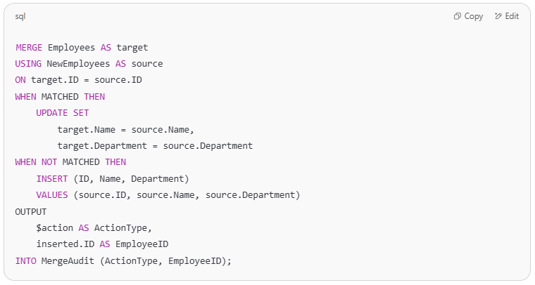
MERGE Employees AS target
USING NewEmployees AS source
ON target.ID = source.ID
WHEN MATCHED THEN
UPDATE SET
target.Name = source.Name,
target.Department = source.Department
WHEN NOT MATCHED THEN
INSERT (ID, Name, Department)
VALUES (source.ID, source.Name, source.Department)
OUTPUT
$action AS ActionType,
inserted.ID AS EmployeeID
INTO MergeAudit (ActionType, EmployeeID);

📋 This logs every INSERT or UPDATE action that occurred during the merge.

✅ Use Case 5: Merge with Complex Join Conditions
# Source: AI Source: Provided by: [Data Path: Persons Table -> ID Column: 1, Name_En Column: Motasem Essam] -> From: [ChatGPT] on [6/11/2026]
Example: Merge based on ID and matching part of a Name
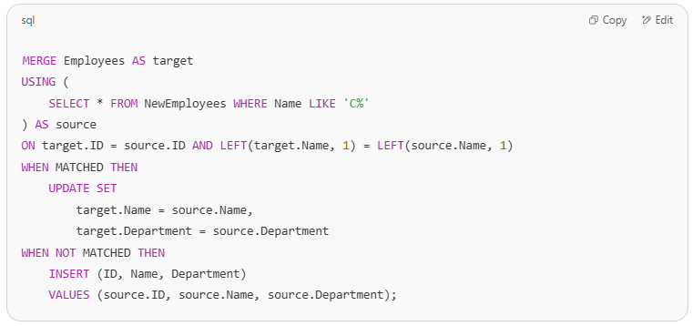
MERGE Employees AS target
USING (
SELECT * FROM NewEmployees WHERE Name LIKE 'C%'
) AS source
ON target.ID = source.ID AND LEFT(target.Name, 1) = LEFT(source.Name, 1)
WHEN MATCHED THEN
UPDATE SET
target.Name = source.Name,
target.Department = source.Department
WHEN NOT MATCHED THEN
INSERT (ID, Name, Department)
VALUES (source.ID, source.Name, source.Department);

🔍 You can customize ON conditions to include partial matches, string patterns, or date ranges.

⚠️ Reminder: MySQL Doesn't Support MERGE
# Source: AI Source: Provided by: [Data Path: Persons Table -> ID Column: 1, Name_En Column: Motasem Essam] -> From: [ChatGPT] on [6/11/2026]
In MySQL, you'd need to manually:
- Use INSERT ... ON DUPLICATE KEY UPDATE
- Follow it up with DELETE or UPDATE using NOT EXISTS, LEFT JOIN, etc.

MySQL
# Source: AI Source: Provided by: [Data Path: Persons Table -> ID Column: 1, Name_En Column: Motasem Essam] -> From: [ChatGPT] on [6/11/2026]
Perfect — let's walk through how to simulate advanced MERGE logic in MySQL, since MySQL does not have a MERGE statement like SQL Server. We'll replicate the following use cases using MySQL-compatible syntax.
✅ Step-by-Step Advanced MERGE in MySQL
We'll simulate these use cases:
- 🔄 Update only if data has changed
- ❌ Soft delete rows not in source
- 🔠 Conditional logic in UPDATE
- 🧾 Audit log of changes
- 🧠 Merge using complex JOIN conditions

🧱 Setup: Create Tables
# Source: AI Source: Provided by: [Data Path: Persons Table -> ID Column: 1, Name_En Column: Motasem Essam] -> From: [ChatGPT] on [6/11/2026]
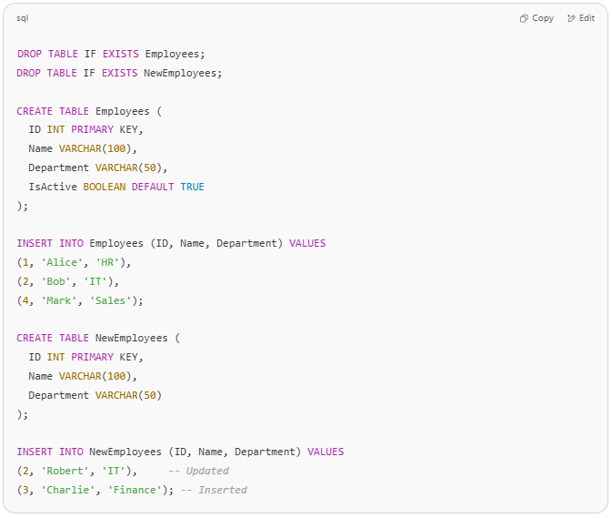
DROP TABLE IF EXISTS Employees;
DROP TABLE IF EXISTS NewEmployees;

CREATE TABLE Employees (
ID INT PRIMARY KEY,
Name VARCHAR(100),
Department VARCHAR(50),
IsActive BOOLEAN DEFAULT TRUE
);

INSERT INTO Employees (ID, Name, Department) VALUES
(1, 'Alice', 'HR'),
(2, 'Bob', 'IT'),
(4, 'Mark', 'Sales');

CREATE TABLE NewEmployees (
ID INT PRIMARY KEY,
Name VARCHAR(100),
Department VARCHAR(50)
);

INSERT INTO NewEmployees (ID, Name, Department) VALUES
(2, 'Robert', 'IT'), -- Updated
(3, 'Charlie', 'Finance'); -- Inserted

✅ 1. Insert or Update Only If Data Has Changed
# Source: AI Source: Provided by: [Data Path: Persons Table -> ID Column: 1, Name_En Column: Motasem Essam] -> From: [ChatGPT] on [6/11/2026]
🧠 Only updates rows if values differ.
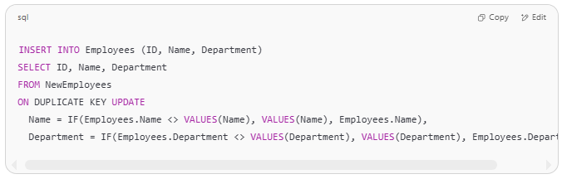
INSERT INTO Employees (ID, Name, Department)
SELECT ID, Name, Department
FROM NewEmployees
ON DUPLICATE KEY UPDATE
Name = IF(Employees.Name <> VALUES(Name), VALUES(Name), Employees.Name),
Department = IF(Employees.Department <> VALUES(Department), VALUES(Department), Employees.Department);

✅ 2. Soft Delete Records Not in Source
# Source: AI Source: Provided by: [Data Path: Persons Table -> ID Column: 1, Name_En Column: Motasem Essam] -> From: [ChatGPT] on [6/11/2026]
❌ This disables records in Employees that aren't in NewEmployees.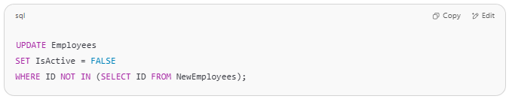
UPDATE Employees
SET IsActive = FALSE
WHERE ID NOT IN (SELECT ID FROM NewEmployees);

✅ 3. Use Conditional Logic in Update
# Source: AI Source: Provided by: [Data Path: Persons Table -> ID Column: 1, Name_En Column: Motasem Essam] -> From: [ChatGPT] on [6/11/2026]
Update names to UPPERCASE only if the department is 'IT':
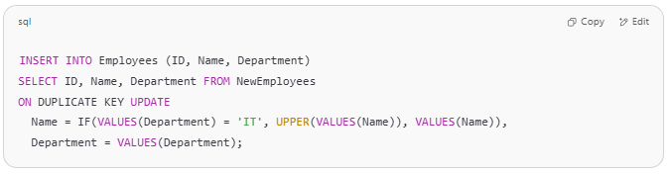
INSERT INTO Employees (ID, Name, Department)
SELECT ID, Name, Department FROM NewEmployees
ON DUPLICATE KEY UPDATE
Name = IF(VALUES(Department) = 'IT', UPPER(VALUES(Name)), VALUES(Name)),
Department = VALUES(Department);

✅ 4. Add Logging (Audit Table)
# Source: AI Source: Provided by: [Data Path: Persons Table -> ID Column: 1, Name_En Column: Motasem Essam] -> From: [ChatGPT] on [6/11/2026]
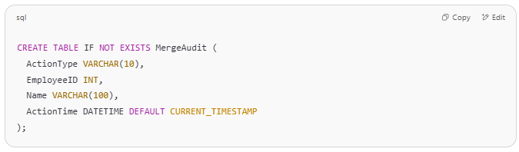
CREATE TABLE IF NOT EXISTS MergeAudit (
ActionType VARCHAR(10),
EmployeeID INT,
Name VARCHAR(100),
ActionTime DATETIME DEFAULT CURRENT_TIMESTAMP
);

Now simulate a merge and log changes: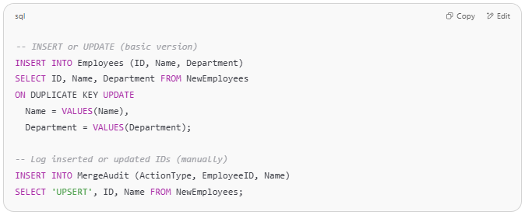
-- INSERT or UPDATE (basic version)
INSERT INTO Employees (ID, Name, Department)
SELECT ID, Name, Department FROM NewEmployees
ON DUPLICATE KEY UPDATE
Name = VALUES(Name),
Department = VALUES(Department);

-- Log inserted or updated IDs (manually)
INSERT INTO MergeAudit (ActionType, EmployeeID, Name)
SELECT 'UPSERT', ID, Name FROM NewEmployees;

You can make this smarter with triggers if needed.

✅ 5. Merge with Complex JOIN Conditions
# Source: AI Source: Provided by: [Data Path: Persons Table -> ID Column: 1, Name_En Column: Motasem Essam] -> From: [ChatGPT] on [6/11/2026]
For example: Only merge names starting with 'C':
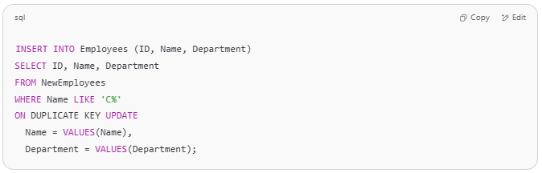
INSERT INTO Employees (ID, Name, Department)
SELECT ID, Name, Department
FROM NewEmployees
WHERE Name LIKE 'C%'
ON DUPLICATE KEY UPDATE
Name = VALUES(Name),
Department = VALUES(Department);

✅ Final Result
# Source: AI Source: Provided by: [Data Path: Persons Table -> ID Column: 1, Name_En Column: Motasem Essam] -> From: [ChatGPT] on [6/11/2026]
Run this full series in MySQL to simulate an advanced MERGE. It’s modular and works across versions.

Example

prepared commands
# Source: ScreenShot Source: Provided by: [Persons Table -> ID Column: 1, Name_En Column: Motasem Essam] -> Tool: [Automation Table -> ID Column: 16, Name_En Column: Screen Capture] -> From [Operating System: Wampserver64 -> phpmyadmin] on [6/11/2026]

CREATE DATABASE testDB;

✅ Step 1: Create Tables
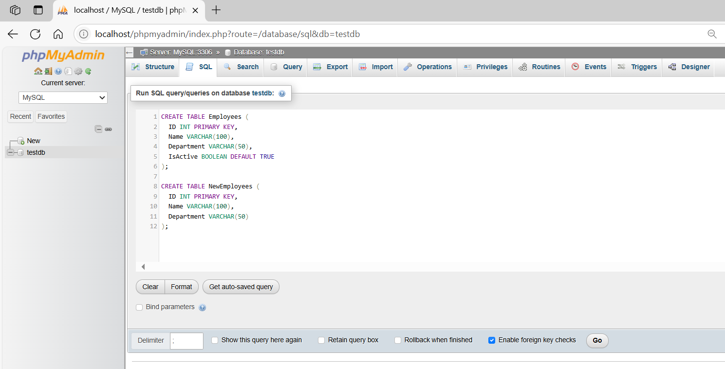
CREATE TABLE Employees (
ID INT PRIMARY KEY,
Name VARCHAR(100),
Department VARCHAR(50),
IsActive BOOLEAN DEFAULT TRUE
);

CREATE TABLE NewEmployees (
ID INT PRIMARY KEY,
Name VARCHAR(100),
Department VARCHAR(50)
);
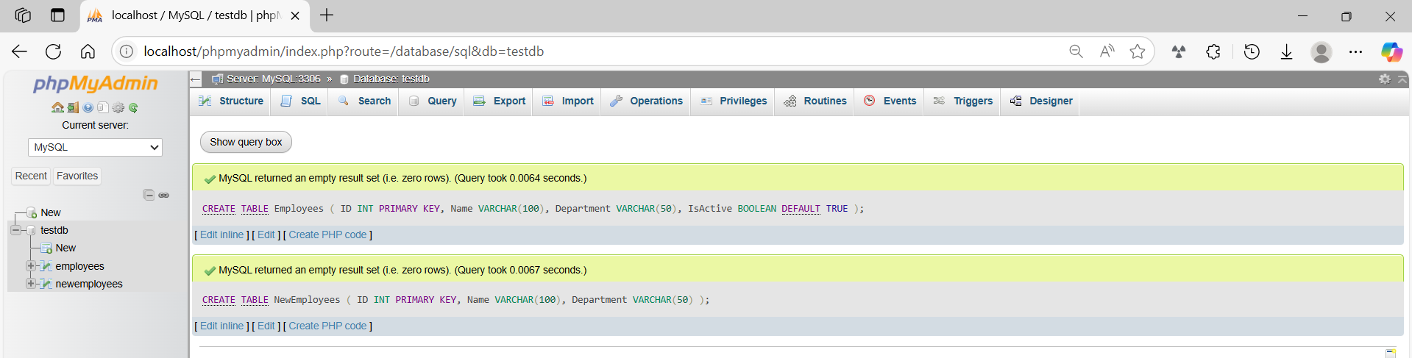
✅ Step 2: Insert Data
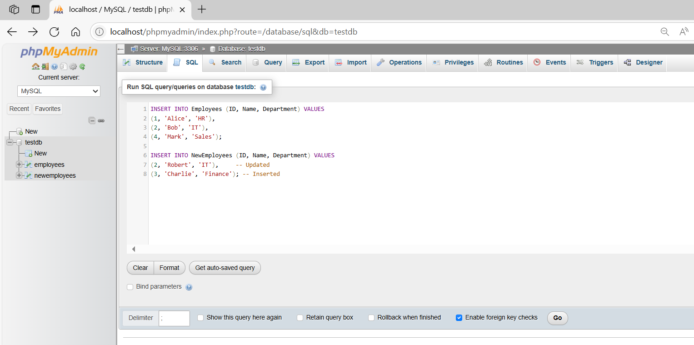
INSERT INTO Employees (ID, Name, Department) VALUES
(1, 'Alice', 'HR'),
(2, 'Bob', 'IT'),
(4, 'Mark', 'Sales');

INSERT INTO NewEmployees (ID, Name, Department) VALUES
(2, 'Robert', 'IT'), -- Updated
(3, 'Charlie', 'Finance'); -- Inserted
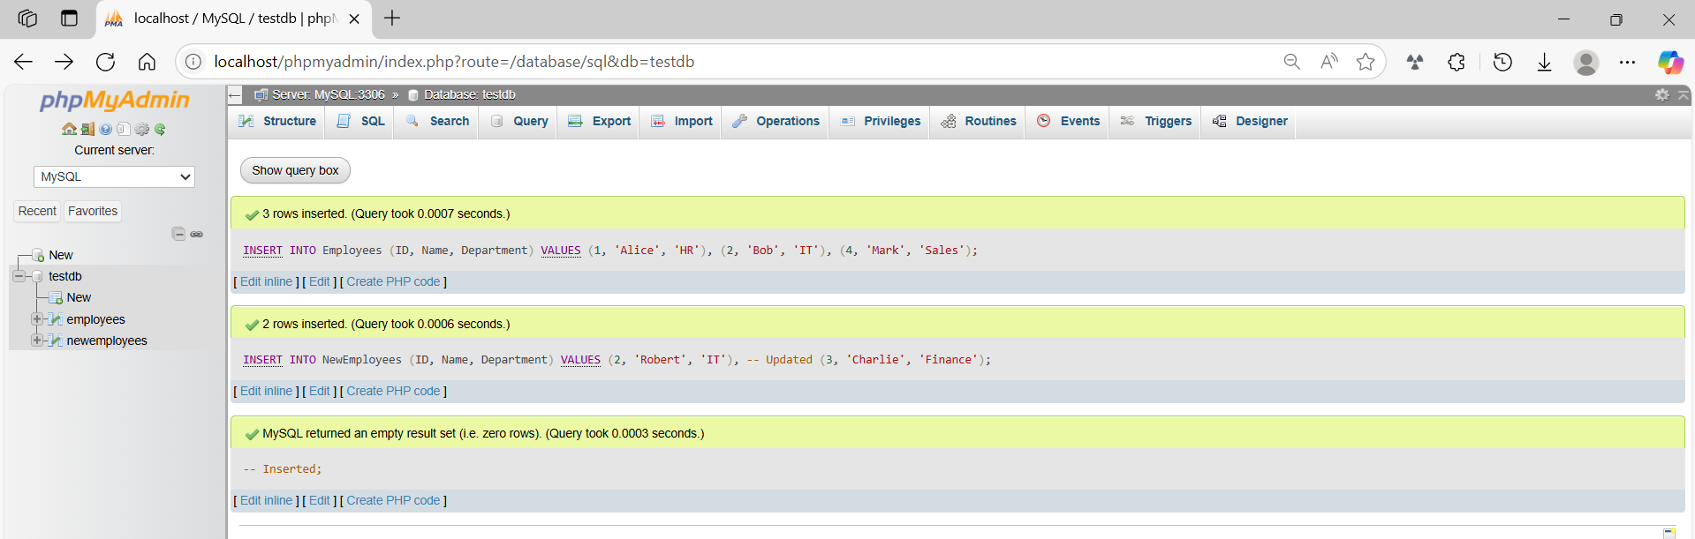
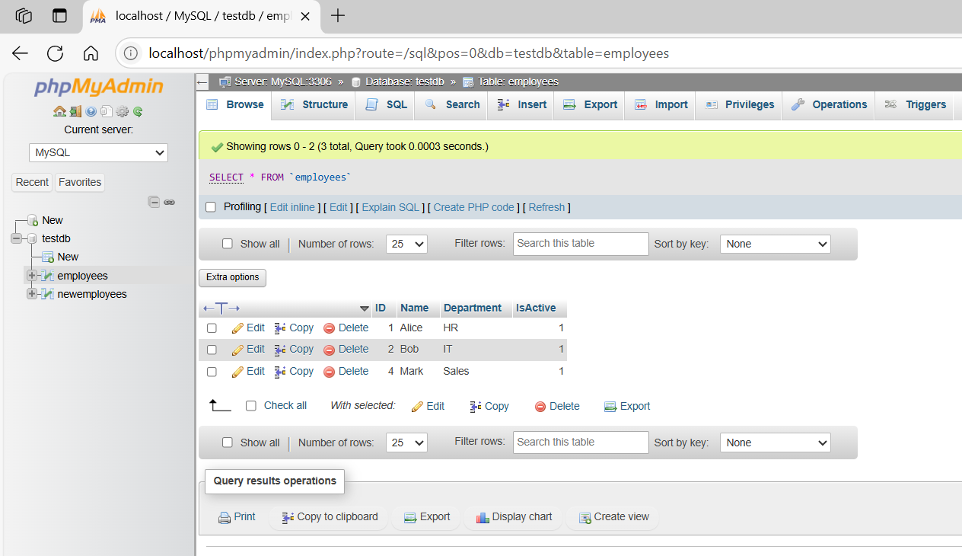
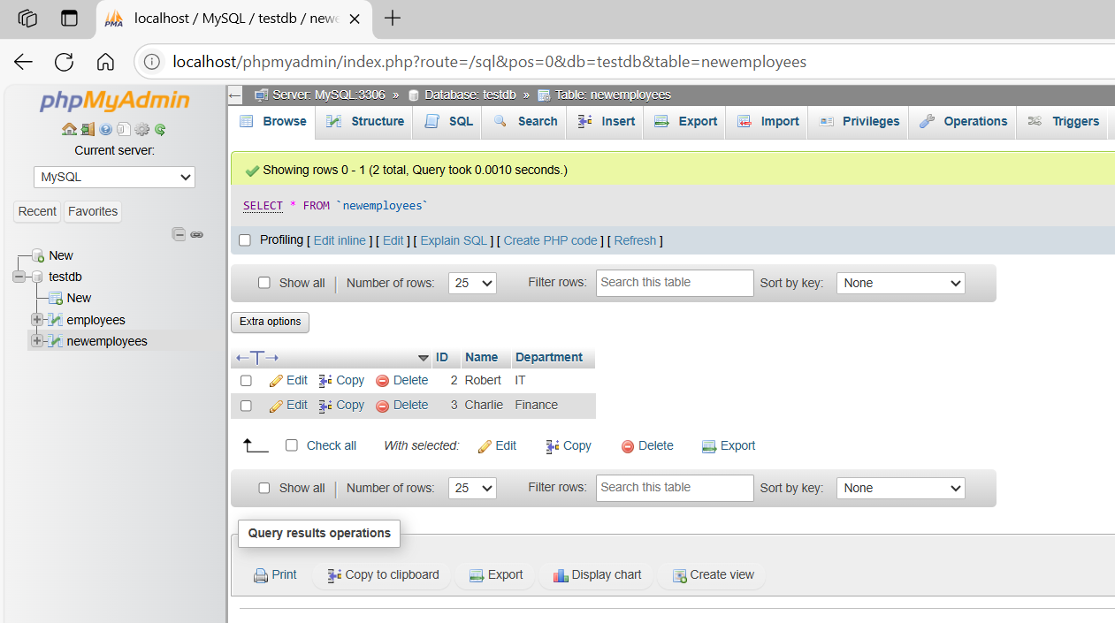

basic command
# Source: ScreenShot Source: Provided by: [Persons Table -> ID Column: 1, Name_En Column: Motasem Essam] -> Tool: [Automation Table -> ID Column: 16, Name_En Column: Screen Capture] -> From [Operating System: Wampserver64 -> phpmyadmin] on [6/11/2026]
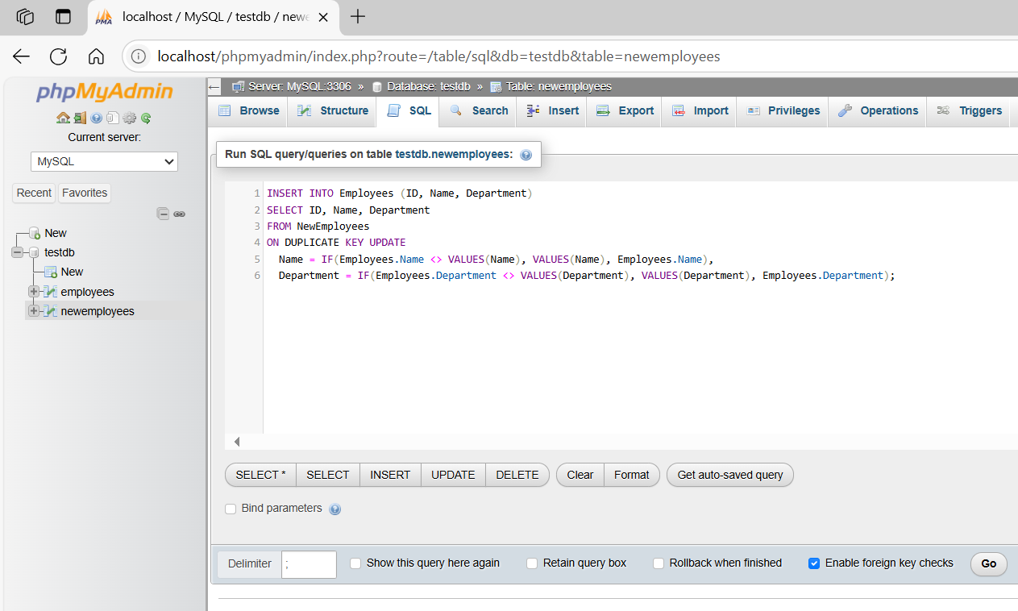
INSERT INTO Employees (ID, Name, Department)
SELECT ID, Name, Department
FROM NewEmployees
ON DUPLICATE KEY UPDATE
Name = IF(Employees.Name <> VALUES(Name), VALUES(Name), Employees.Name),
Department = IF(Employees.Department <> VALUES(Department), VALUES(Department), Employees.Department);
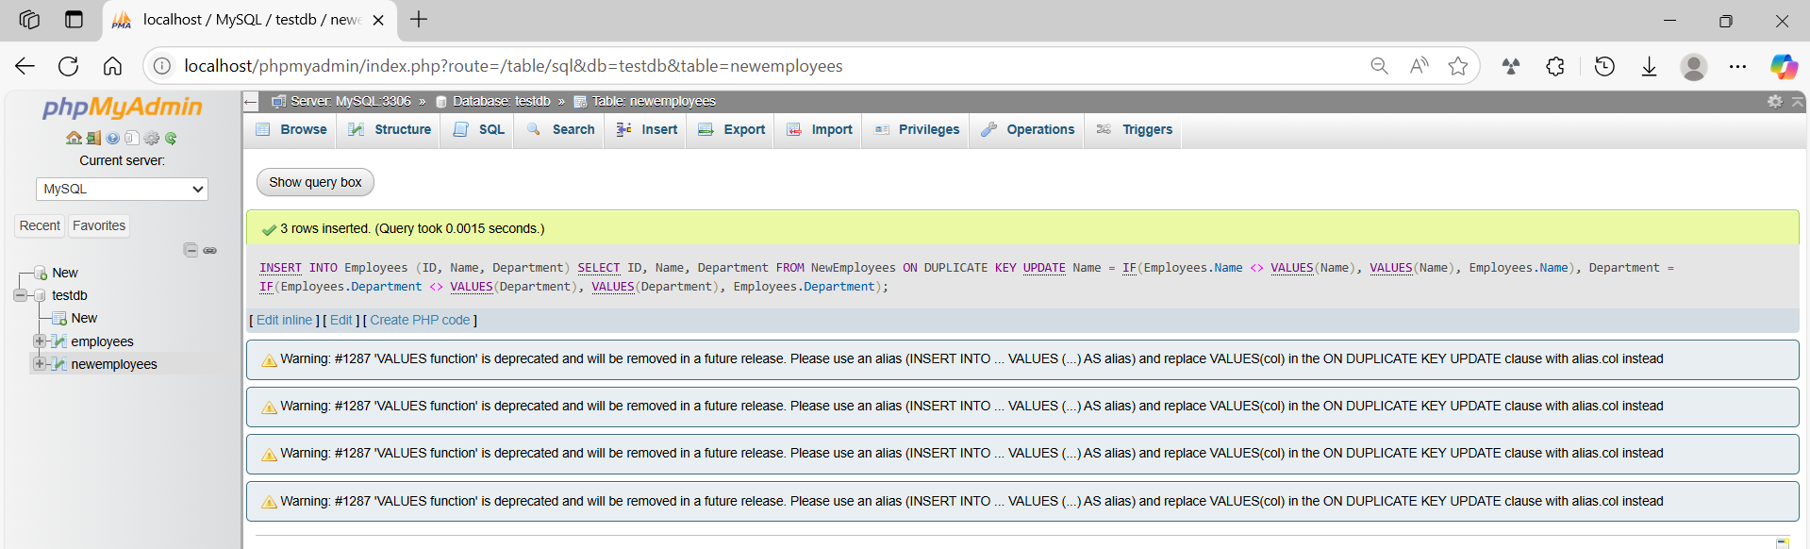
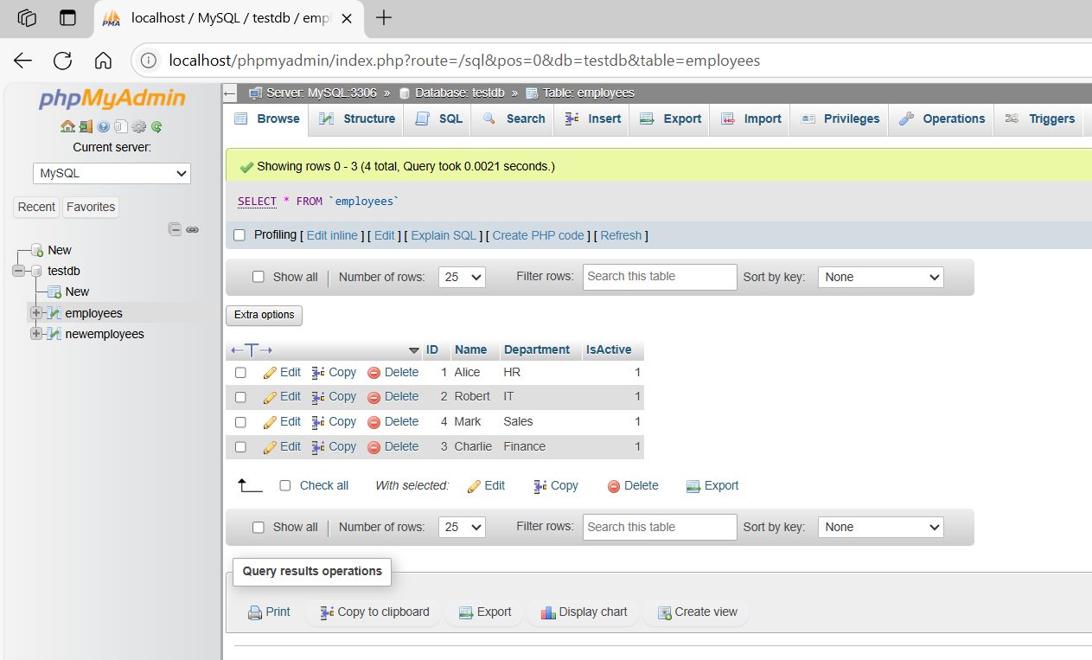
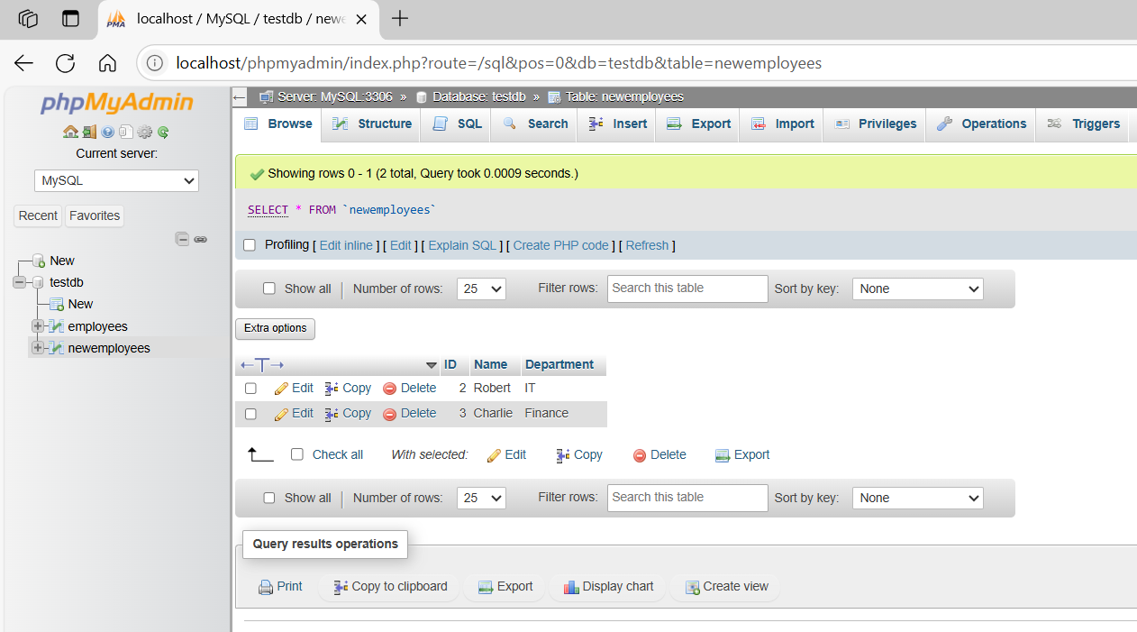

basic command
# Source: ScreenShot Source: Provided by: [Persons Table -> ID Column: 1, Name_En Column: Motasem Essam] -> Tool: [Automation Table -> ID Column: 16, Name_En Column: Screen Capture] -> From [Operating System: Wampserver64 -> phpmyadmin] on [6/11/2026]
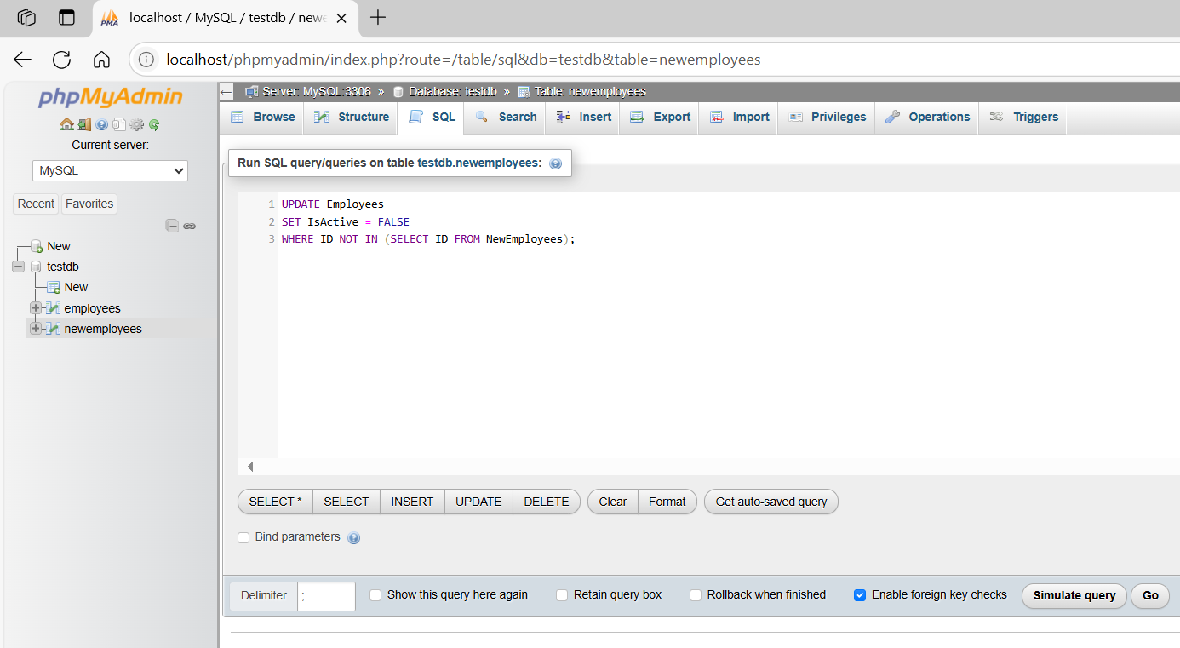
UPDATE Employees
SET IsActive = FALSE
WHERE ID NOT IN (SELECT ID FROM NewEmployees);
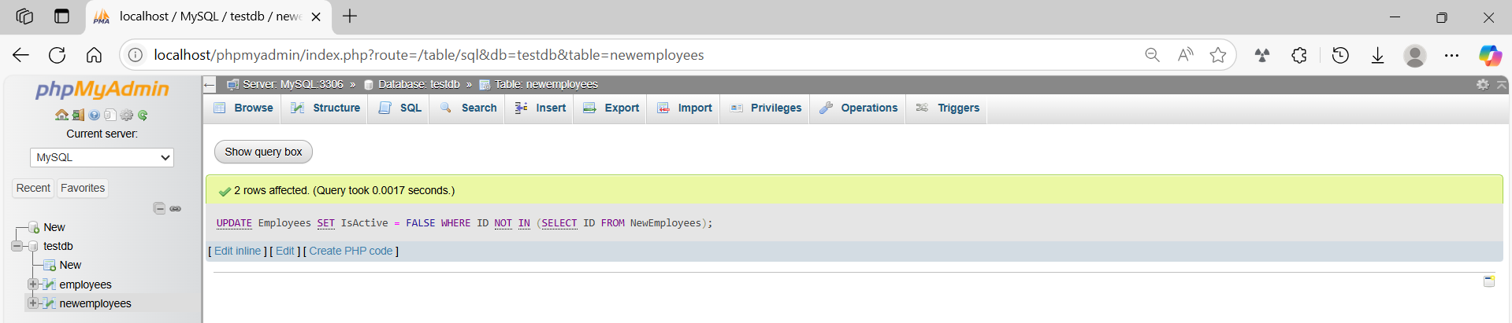
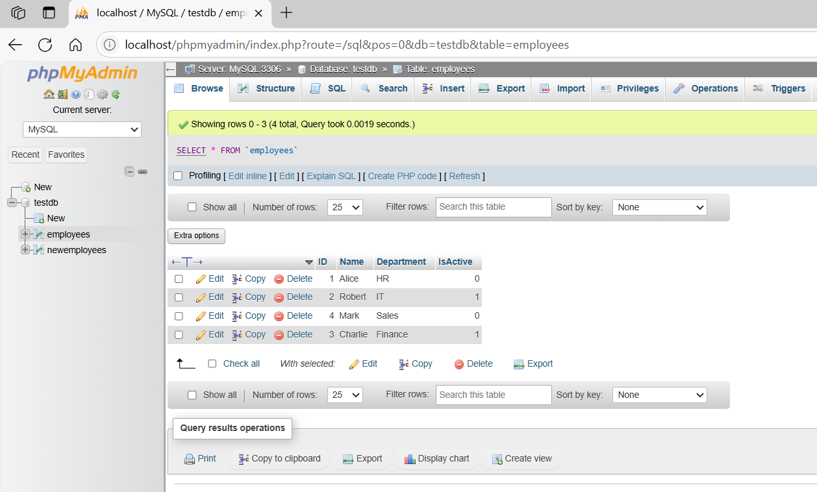
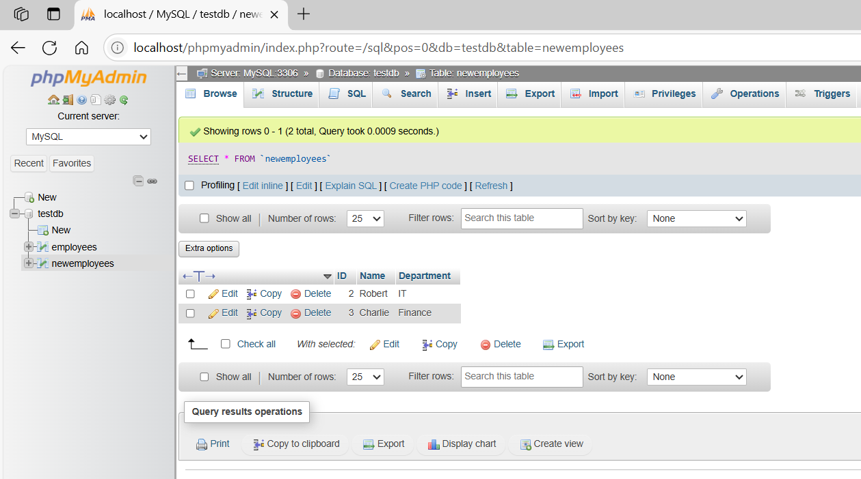

basic command
# Source: ScreenShot Source: Provided by: [Persons Table -> ID Column: 1, Name_En Column: Motasem Essam] -> Tool: [Automation Table -> ID Column: 16, Name_En Column: Screen Capture] -> From [Operating System: Wampserver64 -> phpmyadmin] on [6/11/2026]
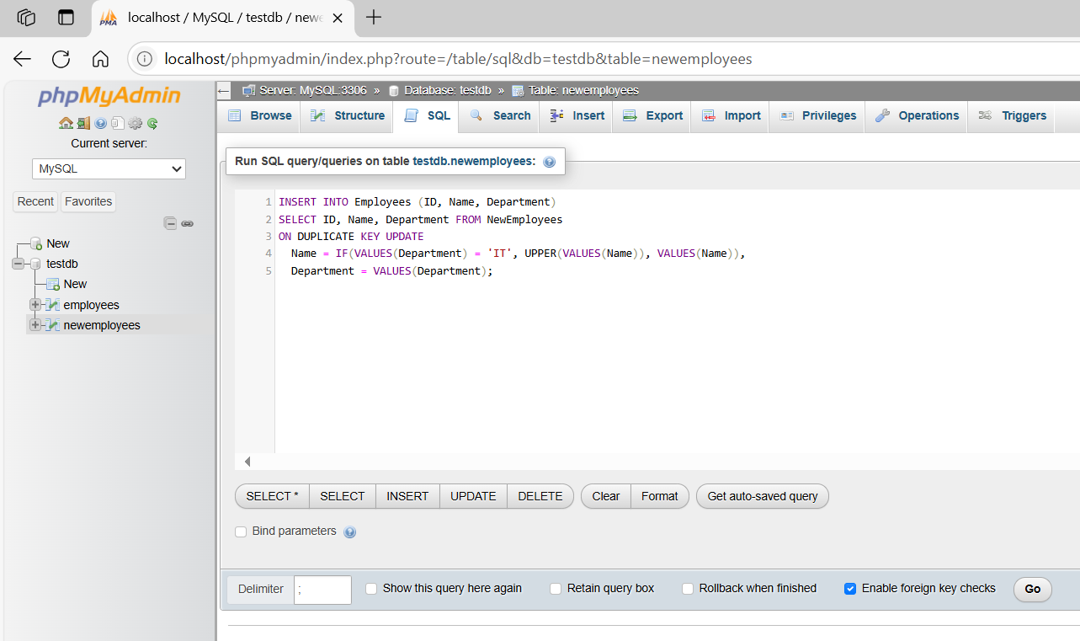
INSERT INTO Employees (ID, Name, Department)
SELECT ID, Name, Department FROM NewEmployees
ON DUPLICATE KEY UPDATE
Name = IF(VALUES(Department) = 'IT', UPPER(VALUES(Name)), VALUES(Name)),
Department = VALUES(Department);
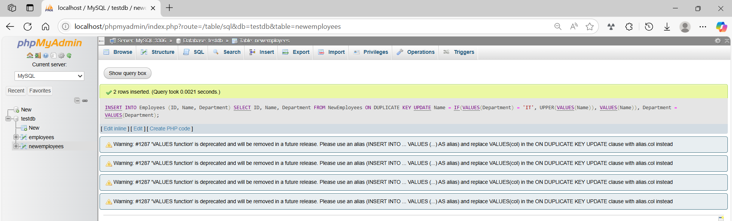
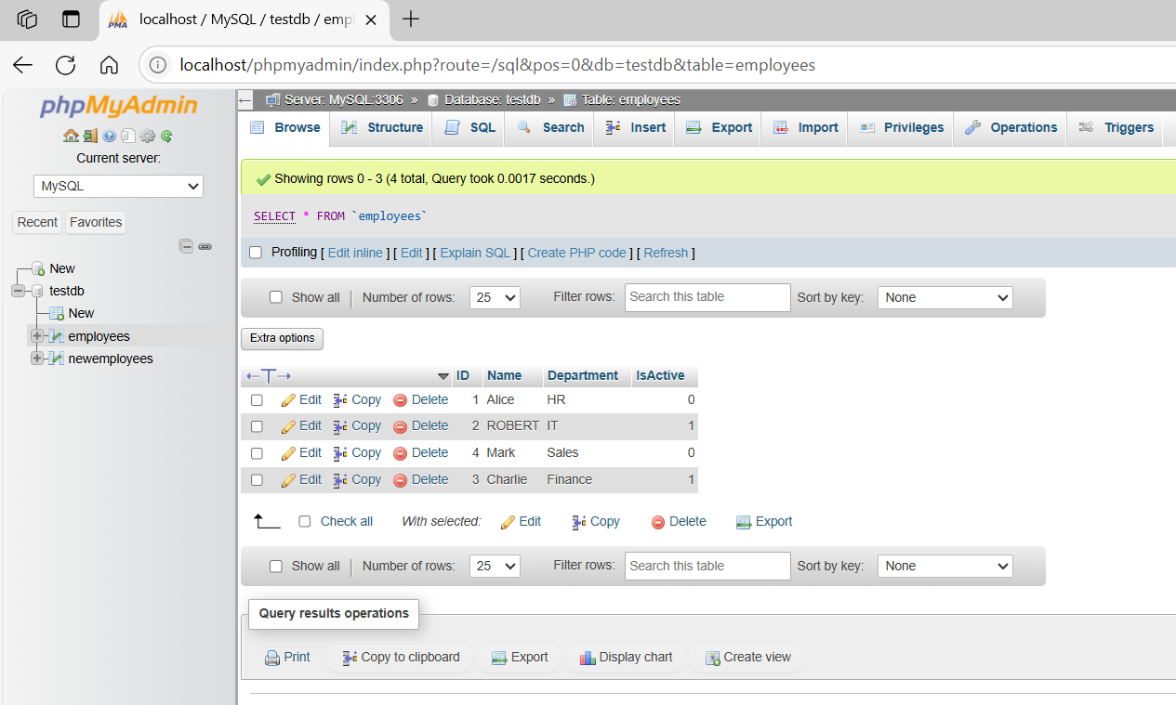
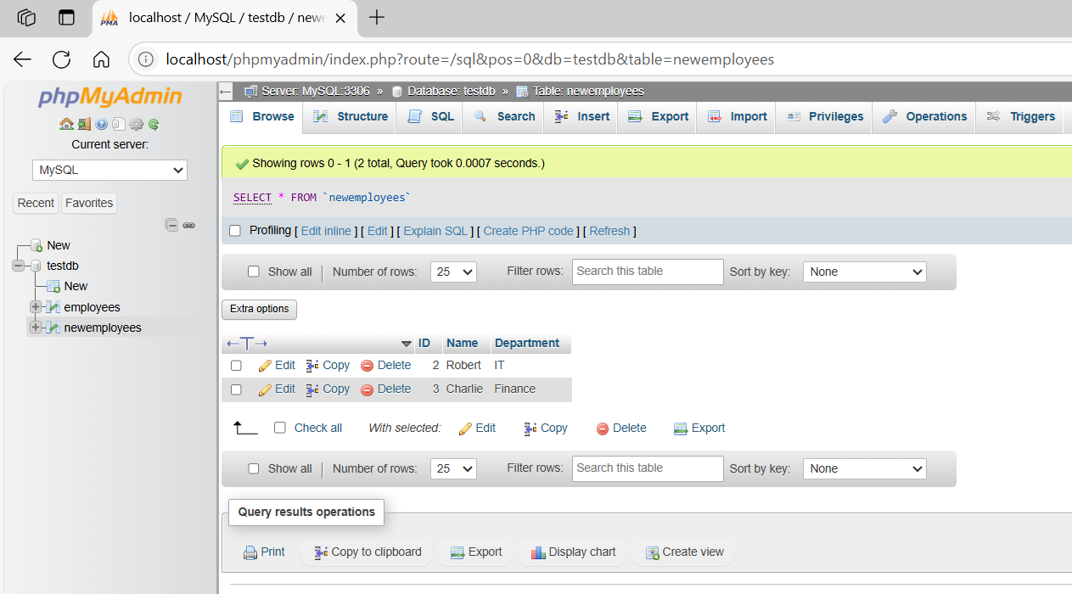

basic command
# Source: ScreenShot Source: Provided by: [Persons Table -> ID Column: 1, Name_En Column: Motasem Essam] -> Tool: [Automation Table -> ID Column: 16, Name_En Column: Screen Capture] -> From [Operating System: Wampserver64 -> phpmyadmin] on [6/11/2026]
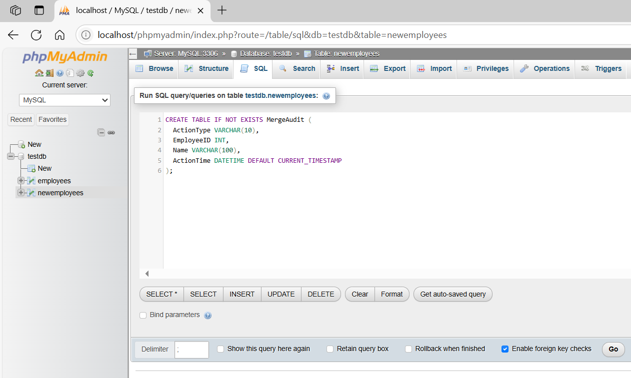
CREATE TABLE IF NOT EXISTS MergeAudit (
ActionType VARCHAR(10),
EmployeeID INT,
Name VARCHAR(100),
ActionTime DATETIME DEFAULT CURRENT_TIMESTAMP
);
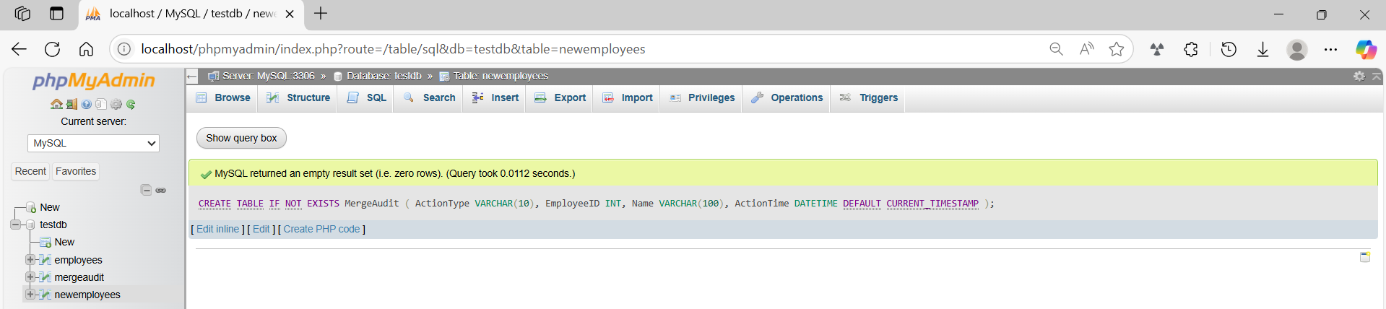
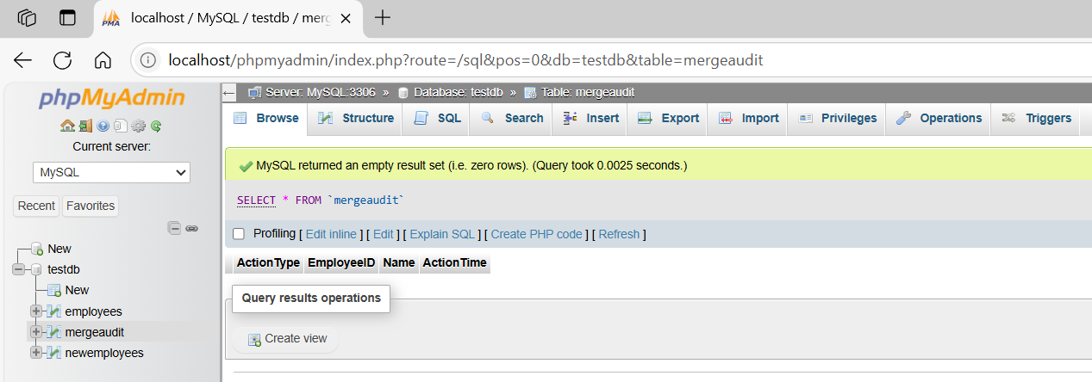
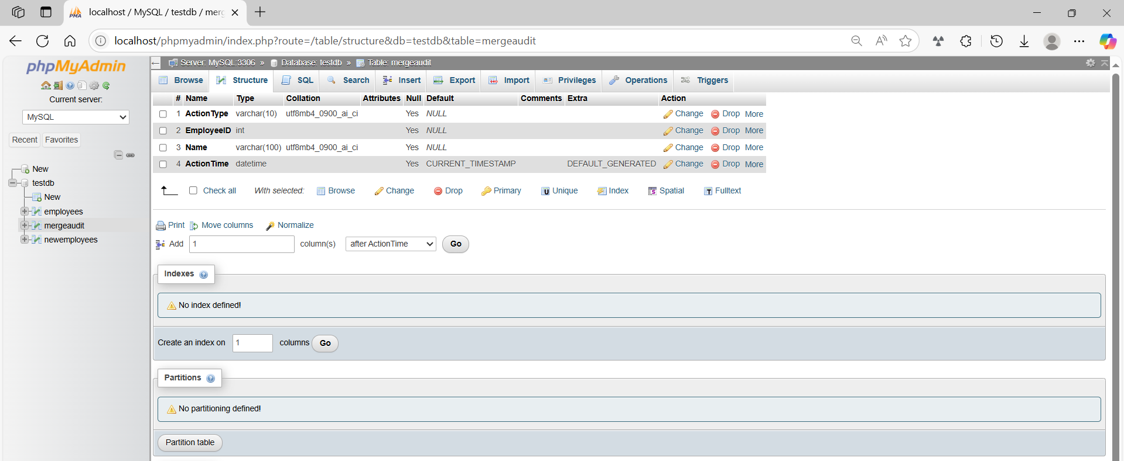
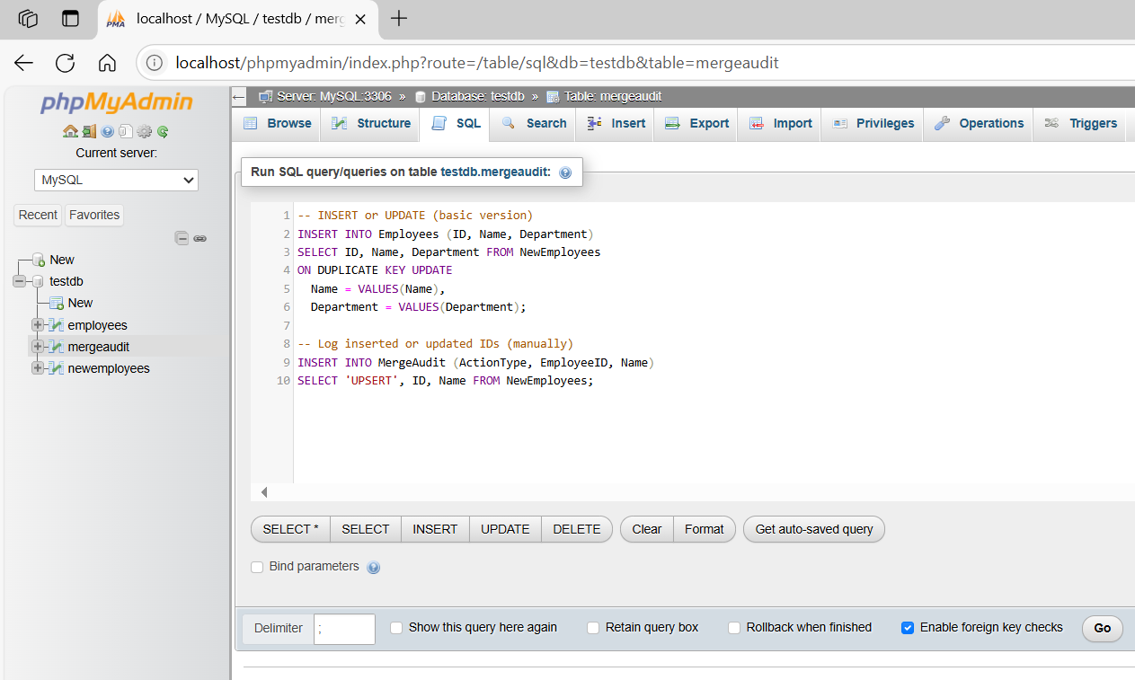
-- INSERT or UPDATE (basic version)
INSERT INTO Employees (ID, Name, Department)
SELECT ID, Name, Department FROM NewEmployees
ON DUPLICATE KEY UPDATE
Name = VALUES(Name),
Department = VALUES(Department);

-- Log inserted or updated IDs (manually)
INSERT INTO MergeAudit (ActionType, EmployeeID, Name)
SELECT 'UPSERT', ID, Name FROM NewEmployees;
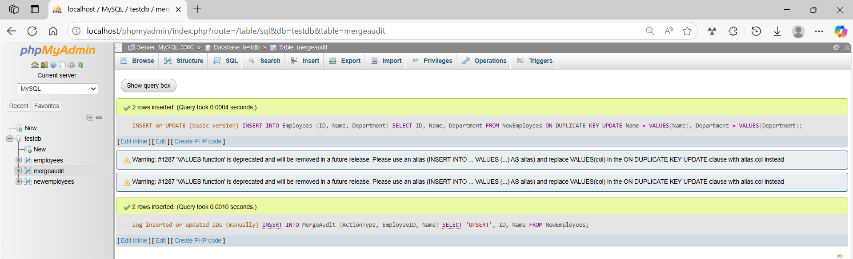
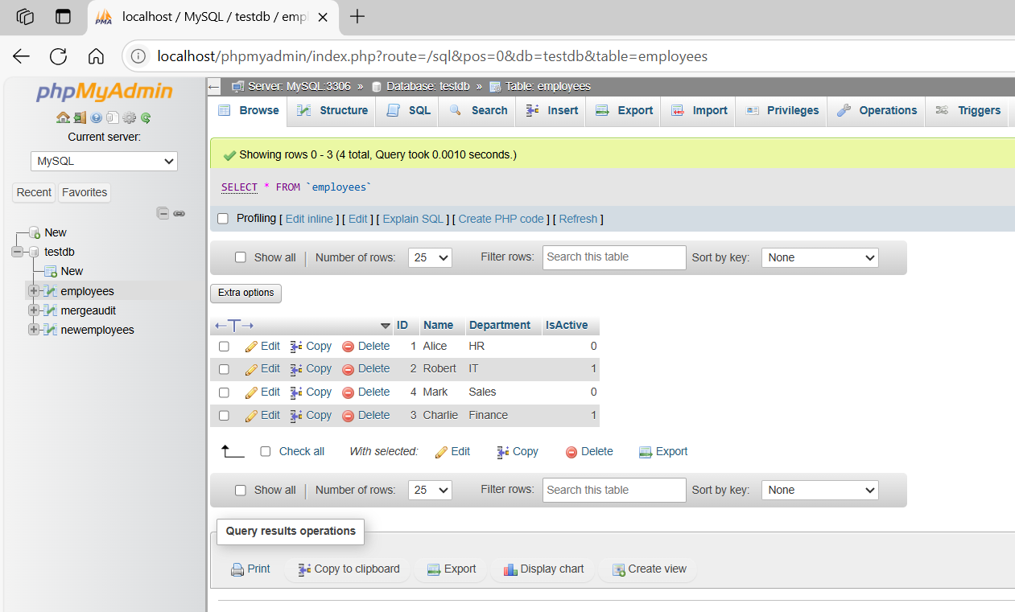
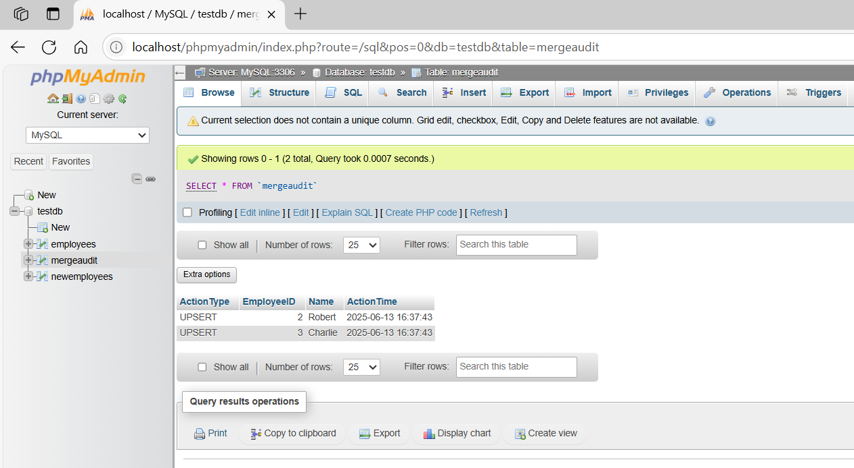
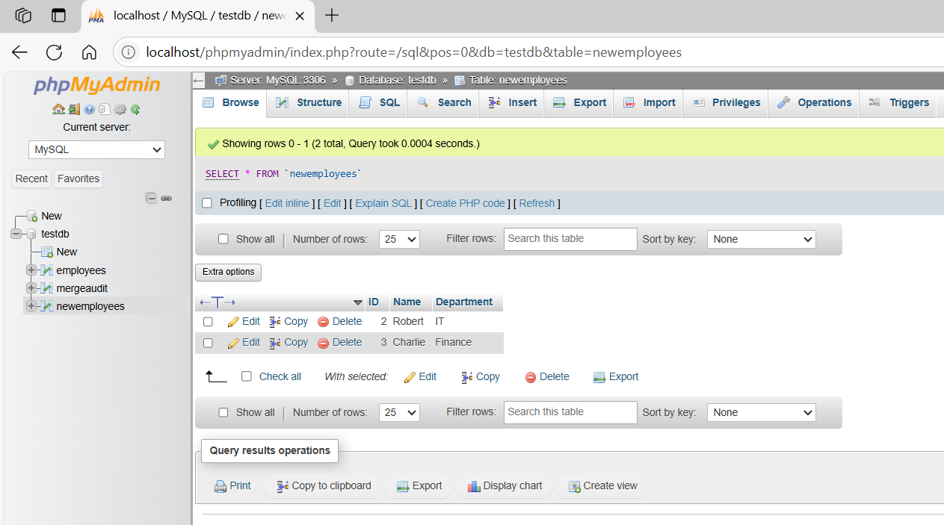

basic command
# Source: ScreenShot Source: Provided by: [Persons Table -> ID Column: 1, Name_En Column: Motasem Essam] -> Tool: [Automation Table -> ID Column: 16, Name_En Column: Screen Capture] -> From [Operating System: Wampserver64 -> phpmyadmin] on [6/11/2026]
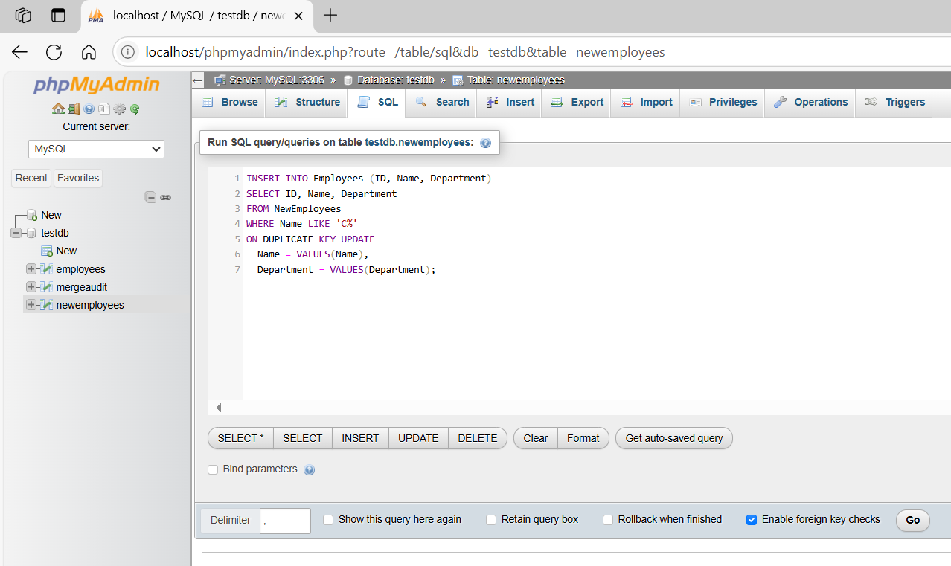
INSERT INTO Employees (ID, Name, Department)
SELECT ID, Name, Department
FROM NewEmployees
WHERE Name LIKE 'C%'
ON DUPLICATE KEY UPDATE
Name = VALUES(Name),
Department = VALUES(Department);
